Safe Bathroom Checklist
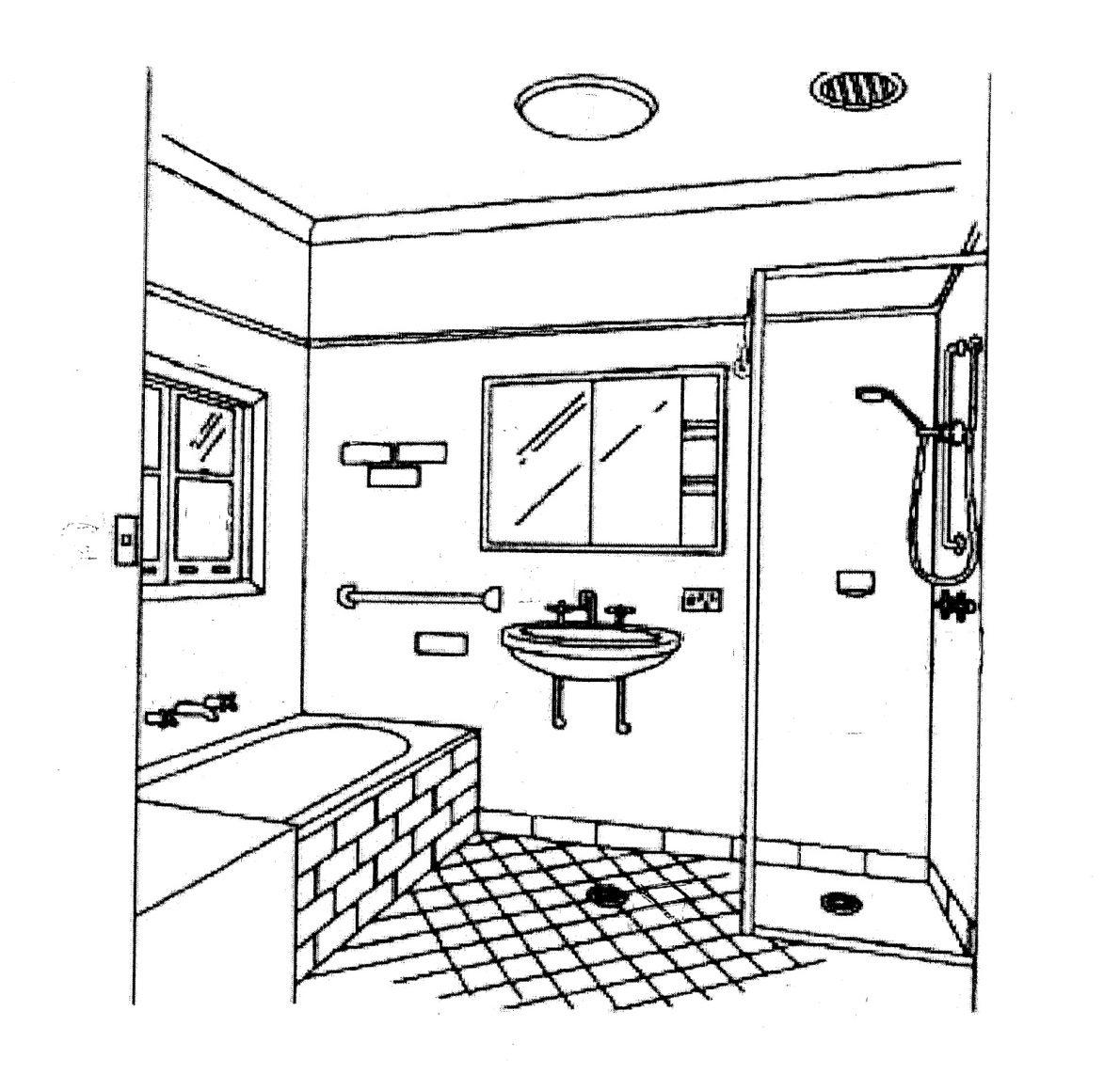
Community _________________________________ EH Practitioner_____________________

House identifier _____________________________ Date _____________________________

Item (diagram) | Bathroom item | Issue | Yes | No | Notes | EHP action |  |  | Referral to Housing agency (date)
 |  |  | (please circle) |  |  | (please circle)
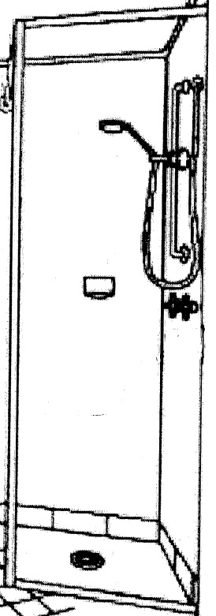  Shower | Shower taps | Hot tap | Yes | No |  | Fix | Replace | Clean
 |  | Cold tap | Yes | No |  | Fix | Replace | Clean
 | Shower Water flow | Hot water | Yes | No |  | Fix | Replace | Clean
 |  | Cold water | Yes | No |  | Fix | Replace | Clean
 | Shower rose | Does it work? | Yes | No |  | Fix | Replace | Clean
 | Shower drain | Grate | Yes | No |  | Fix | Replace | Clean
 |  | Shower drain works | Yes | No |  | Fix | Replace | Clean
 | Shower Soap holder | Shower soap holder | Yes | No |  | Fix | Replace | Clean
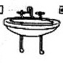  Hand Basin | Hand basin | Basin is safe | Yes | No |  | Fix | Replace | Clean
 | Basin taps | Hot tap | Yes | No |  | Fix | Replace | Clean
 |  | Cold tap | Yes | No |  | Fix | Replace | Clean
 | Basin Water flow | Hot water | Yes | No |  | Fix | Replace | Clean
 |  | Cold water | Yes | No |  | Fix | Replace | Clean
 | Basin cabinet | Cabinet is present | Yes | No |  | Fix | Replace | Clean
 |  | Cabinet is functional | Yes | No |  | Fix | Replace | Clean
 | Basin Drain | Basin drain works | Yes | No |  | Fix | Replace | Clean
Item (diagram) | Bathroom item | Issue | Yes | No | Notes | EHP action |  |  | Referral to Housing agency (date)
 |  |  | (please circle) |  |  | (please circle)
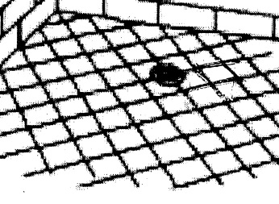  Floor | Floor surface | Safe | Yes | No |  | Fix | Replace | Clean
 | Floor waste | Grate | Yes | No |  | Fix | Replace | Clean
 |  | Floor waste works | Yes | No |  | Fix | Replace | Clean
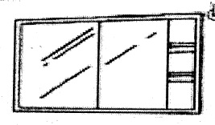  Mirror | Mirror | Mirror present | Yes | No |  | Fix | Replace | Clean
 |  | Mirror is safe | Yes | No |  | Fix | Replace | Clean
 |  | Kids can see their face | Yes | No |  | Fix | Replace | Clean
Towel Rail/Hook(s) | Towel rail / hooks | Towels can be hung up | Yes | No |  | Fix | Replace | Clean
 |  | Towels can be hung seperately | Yes | No |  | Fix | Replace | Clean
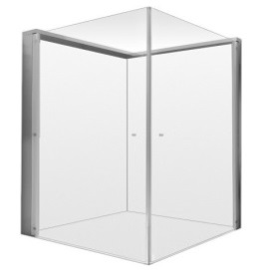  Shower Screen | Shower screen | There is one | Yes | No |  | Fix | Replace | Clean
 |  | It works | Yes | No |  | Fix | Replace | Clean
 |  | It is clean | Yes | No |  | Fix | Replace | Clean

Item (diagram) | Bathroom item | Issue | Yes | No | Notes | EHP action |  |  | Referral to Housing agency (date)
 |  |  | (please circle) |  |  | (please circle)
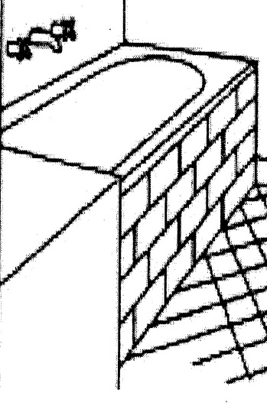  Bath | Bath | There is one | Yes | No |  | Fix | Replace | Clean
 |  | Bath is safe | Yes | No |  | Fix | Replace | Clean
 | Bath taps | Hot tap | Yes | No |  | Fix | Replace | Clean
 |  | Cold tap | Yes | No |  | Fix | Replace | Clean
 | Water flow | Hot water | Yes | No |  | Fix | Replace | Clean
 |  | Cold water | Yes | No |  | Fix | Replace | Clean
 | Bath drain | Grate | Yes | No |  | Fix | Replace | Clean
 |  | Drain works | Yes | No |  | Fix | Replace | Clean
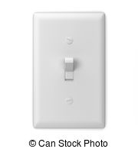  Light | Light | Switch is safe | Yes | No |  | Fix | Replace | Clean
 |  | Light works | Yes | No |  | Fix | Replace | Clean
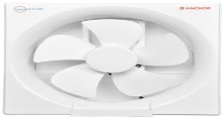  Exhaust fan | Exhaust fan | Switch is safe | Yes | No |  | Fix | Replace | Clean
 |  | Fan works | Yes | No |  | Fix | Replace | Clean
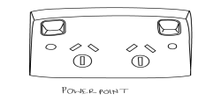  Power point | Power point | Powerpoint works | Yes | No |  | Fix | Replace | Clean
 |  | Powerpoint is safe | Yes | No |  | Fix | Replace | Clean

Item (diagram) | Bathroom item | Issue | Yes | No | Notes | EHP action |  |  | Referral to Housing agency (date)
 |  |  | (please circle) |  |  | (please circle)
Walls & Ceilings | Walls and ceilings | Walls and ceilings are intact | Yes | No |  | Fix | Replace | Clean
 |  | No visable water damage | Yes | No |  | Fix | Replace | Clean
 |  | No mould present | Yes | No |  | Fix | Replace | Clean
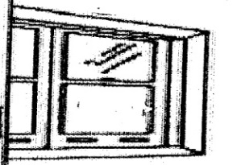  Window | Window glass | Glass is intact | Yes | No |  | Fix | Replace | Clean
 | Window | Opens and closes | Yes | No |  | Fix | Replace | Clean

Door | Bathroom door | Door is intact | Yes | No |  | Fix | Replace | Clean
 |  | Door opens and closes | Yes | No |  | Fix | Replace | Clean
 |  | Door lock works | Yes | No |  | Fix | Replace | Clean

Other Important Bathroom Items
1 | Soap was present | In the Shower |  | At the Basin
 |  | - Yes | - No | - Yes | - No
2 | How many people use this bathroom ? |  |  | (no of people)
3 | Does everyone have their own towel ? |  |  | - Yes | - No
4 | Can each towel be hung up in the bathroom ? |  |  | - Yes | - No
5 | Did you install towel hangers or towel rails ? |  |  | - Yes | - No
6 | How many towels given to this house ? |  |  | _______ (quantity)
7 | How many bars of soap given to this house ? |  |  | _______ (quantity)
8 | How many soap holders installed ? |  |  | _______(quantity)
9 | New mirror installed ? |  |  | - Yes | - No
10 | Face and Hand washing sticker in place? |  |  | - Yes | - No
11 | Did you replace the Face and Hand washing sticker? |  |  | - Yes | - No
12 | Did you have a conversation about Face and Hand washing? |  |  | - Yes | - No

Notes:

