Foodborne disease surveillance and outbreak investigations in Western Australia 2019 annual report



**Enhancing foodborne disease surveillance across Australia**



OzFoodNet, Communicable Disease Control Directorate

**Acknowledgments**

Acknowledgement is given to the following people for their assistance with the activities described in this report: the staff from PathWest Laboratory Medicine WA; Mr John Coles and other staff from the Environmental Health Directorate of the Department of Health, Western Australia; Public Health Nurses from the metropolitan and regional Population Health Units; and Local Government Environmental Health Officers.

**Contributors/Editors**

Liana Varrone, Benjamin Witham, Nevada Pingault

Communicable Disease Control Directorate

Department of Health, Western Australia

PO Box 8172

Perth Business Centre

Western Australia 6849

Email: [OzfoodnetWA@health.wa.gov.au](mailto:OzfoodnetWA@health.wa.gov.au)

Telephone: (08) 9222 2152

Facsimile: (08) 9222 0254

Web:

OzFoodNet WA Health

<https://ww2.health.wa.gov.au/Articles/F_I/Infectious-disease-data/Enteric-infection-reports-and-publications-OzFoodNet>

OzFoodNet Department of Health and Ageing

<https://www1.health.gov.au/internet/main/publishing.nsf/Content/cdna-ozfoodnet.htm>

**Disclaimer**:

Every endeavour has been made to ensure that the information provided in this document was accurate at the time of writing. However, infectious disease notification data are continuously updated and subject to change.

PUBLISHED BY

This publication has been produced by the **Department of Health, Western Australia**.

# Executive summary

This report is a summary of enteric disease surveillance activities and outbreak investigations in Western Australia (WA) in 2019. Enteric disease causes a large burden of illness in the WA community. In WA, there are 16 enteric infections that are notifiable to the Department of Health. The Department of Health through OzFoodNet (OFN) and other agencies conducts surveillance and investigates outbreaks so that targeted interventions can be used to help prevent further transmission.

In 2019, there were 7080 notifications of enteric disease in WA, which was a rate of 251 per 100 000 population. The 2019 rate was 12% higher than the mean rate for the previous five years. The age group with the highest enteric disease rate was 0-4 years with 647 cases per 100 000 population. The rate of enteric disease for Aboriginal people was 1.3-fold higher than for non-Aboriginal people. Of the notified enteric infections with a known place of acquisition, 71% reported acquiring their infection in WA, 28% reported overseas travel and 1% reported interstate travel. Of enteric notifications reporting overseas travel, 57% had travelled to Indonesia.

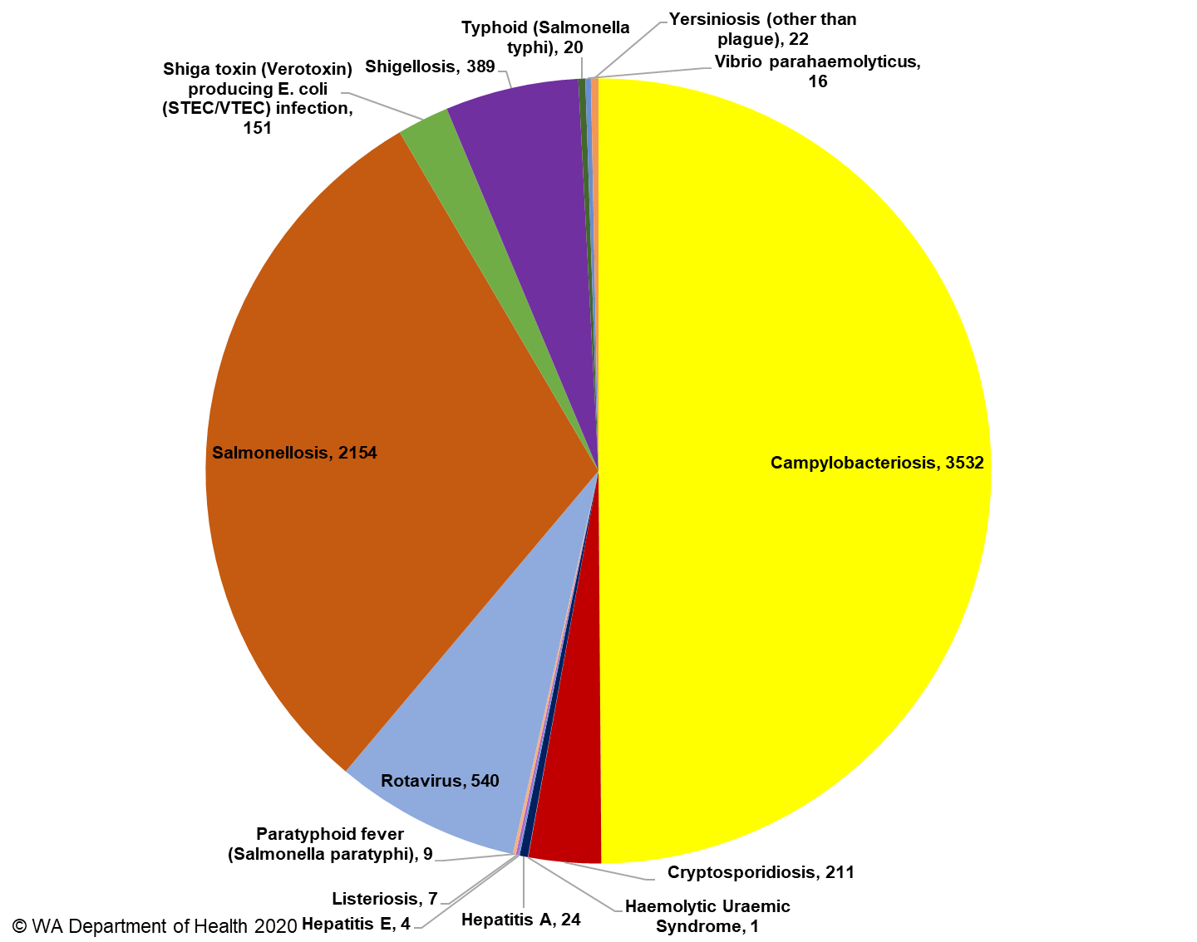

**Figure A: Number of WA enteric disease notifications for 2019 by disease**

Campylobacteriosiswas the most commonly notified enteric disease in 2019 (n=3532) followed by salmonellosis (n=2154) (Figure A); notification rates are 4% and 7% higher than the previous five years, respectively. Shigellosis (n=389) and Shiga toxin-producing *E. coli* infection (n=151) also had higher rates compared to the previous five years. This may be in part due to changes in disease definitions and testing criteria (sections 4.4 and 4.6).

**Foodborne and probable foodborne outbreaks**

In 2019, there were 26 outbreaks of foodborne or probable foodborne disease investigated in WA that caused at least 472 cases of illness. Of these 26 outbreaks, 23 were caused by *Salmonella* Typhimurium, two outbreaks were due to norovirus and one was caused by *Salmonella* Paratyphi B bv Java (Figure B).

Of the 26 outbreaks, there were 13 outbreaks where a food was implicated. Raw or undercooked egg dishes were the most commonly implicated food (n=9, 69%).

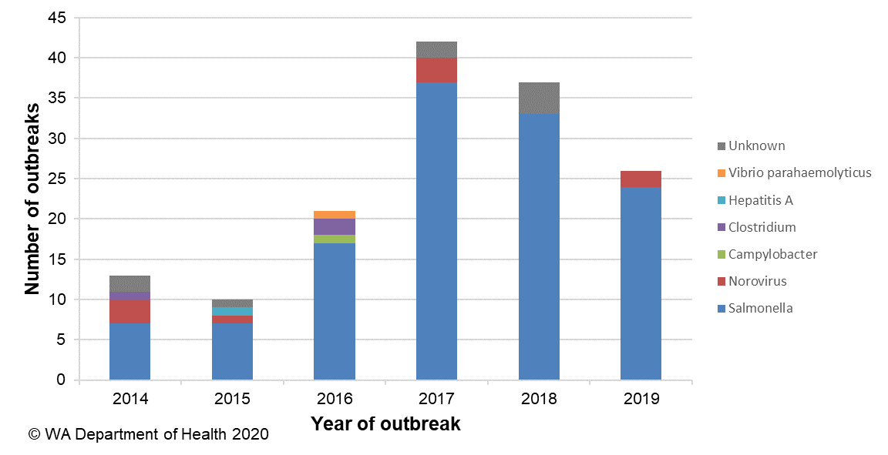

**Figure B: Foodborne outbreaks investigated in WA by causative pathogen**

**Non-foodborne enteric disease outbreaks**

Non-foodborne enteric disease outbreaks and outbreaks with an unknown mode of transmission are a major cause of illness, especially in institutions such as residential care facilities (RCFs) and child care centres (CCCs). There were 149 non-foodborne outbreaks reported in 2019 which resulted in 2324 ill people, 45 hospitalisations and 15 associated deaths. Most of these outbreaks were in RCFs and CCCs and due to person-to-person transmission.

# Table of contents

Executive summary 3

1. Introduction 7

2. Data sources and methods 9

2.1. Data sources 9

2.2. Data collection by Aboriginality 10

2.3. Regional boundaries 10

2.4. Calculation of rates 10

2.5. Definitions 10

3. Site activities including prevention measures during the year 11

3.1. Surveillance and investigation 11

3.2. Activities on enhancing laboratory and epidemiological surveillance 12

3.3. Activities to assist enteric disease policy development 13

3.4. Strengthening skills and capacity for enteric disease surveillance and investigation 13

3.5. Conference meetings and presentations 13

4. Incidence of specific enteric diseases 14

4.1. Campylobacteriosis 14

4.2. Salmonellosis 16

4.3. Rotavirus infection 21

4.4. Shigellosis 23

4.5. Cryptosporidiosis 25

4.6 Shiga toxin-producing *E. coli* infection 27

4.7 Hepatitis A infection 28

4.8 *Yersinia* infection 28

4.9 Typhoid and paratyphoid fever 29

4.10 *Vibrio parahaemolyticus* infection 29

4.11 Listeriosis 29

4.12 Hepatitis E infection 30

4.13 Haemolytic Uraemic Syndrome (HUS) 30

4.14 Cholera 30

4.15 Botulism 30

5 Gastrointestinal disease outbreaks and investigations 31

5.1 Foodborne and probable foodborne outbreaks 31

5.2 Outbreaks due to non-foodborne transmission or with an unknown mode of transmission 35

5.3 Cluster investigations 37

6. References 40

Appendix 1: Number of notifications, notification rate2 and ratio of current to historical mean by pathogen/condition, 2014 to 2019, WA 49

List of tables

Table 1 Number and proportion of the top 10 *Salmonella* serotypes notified in WA, 2019, with comparison to the 5-year average 20

Table 2 The 10 most common *S*. Typhimurium MLVA types reported in 2019 20

Table 3 Foodborne and probable foodborne outbreaks, 2019 33

Table 4 Outbreaks due to non-foodborne transmission or unknown mode of transmission in WA by setting and agent, 2019 37

Table 5 Cluster investigations in WA by month investigation started, setting and agent, 2019 39

List of figures

Figure 1 Number of notifications of campylobacteriosis by year and month of onset, WA, 2014 to 2019 15

Figure 2 Age-specific notification rates for campylobacteriosis by sex, WA, 2019 15

Figure 3 Campylobacteriosis notification rates by region and Aboriginality, WA, 2019 16

Figure 4 Number of notifications of salmonellosis by year and month of onset, WA, 2014 to 2019 17

Figure 5 Age-specific notification rates for salmonellosis by sex, WA, 2019 17

Figure 6 Salmonellosis notification rates by region and Aboriginality, WA, 2019 18

Figure 7 Salmonellosis notifications by place of acquisition, by year of onset, 2013 to 2019 19

Figure 8 Number of notifications of rotavirus infection by year and month of onset, WA, 2014 to 2019 21

Figure 9 Age-specific notification rates for rotavirus by sex, WA, 2019 22

Figure 10 Rotavirus notification rates by region and Aboriginality, WA, 2019 22

Figure 11 Number of notifications of shigellosis by year and month of onset, WA, 2014 to 2019. Probable and confirmed cases are included 23

Figure 12 Age-specific notification rates for shigellosis by sex, WA, 2019 24

Figure 13 Shigellosis notification rates by region and Aboriginality, WA, 2019 24

Figure 14 The three most common *Shigella* types notified in 2019 25

Figure 15 Number of notifications of cryptosporidiosis by year and month of onset, WA, 2014 to 2019 26

Figure 16 Age-specific notification rates for cryptosporidiosis by sex, WA, 2019 26

Figure 17 Cryptosporidiosis notification rates by region and Aboriginality, WA, 2019 27

Figure 18 Place of acquisition for hepatitis A notifications, 2014 to 2019 28

Figure 19 Notifications of listeriosis showing non-pregnancy related infections and deaths, and materno-foetal infections and deaths, WA, 2014 to 2019 30

Figure 20 Number of non-foodborne gastroenteritis outbreaks by mode of transmission and month, 2019 36

Figure 21 Notifications of *Salmonella* Typhimurium MLVA 03-17-09-12-523 in WA 38

# Introduction

It has been estimated that there are 5.4 million cases of foodborne illness in Australia each year and that the cost of this illness is $1.2 billion per year1. This is likely to be an underestimate of the true cost of enteric illness in Australia as not all enteric infections are caused by foodborne transmission. Other modes of transmission such as person-to-person, animal-to-person and waterborne transmission are also very important in enteric infection. Most enteric infections are preventable through interventions at the level of primary production, institution infection control, and food handling and hand hygiene at food businesses and in households.

This report describes Western Australian enteric disease surveillance and investigations carried out in 2019 by OzFoodNet WA (OFN) and other Western Australian government agencies. Most of the data presented in this report is derived from enteric disease notifications from doctors and laboratories received by the Department of Health, WA (WA Health) and are likely to underestimate the true incidence of disease. This data nevertheless remains the most important information on incidence of these infections for surveillance purposes in Western Australia (WA). In addition, norovirus, which is not notifiable, is the cause of a large burden of illness in RCFs and also in the general community.

OFN is part of the Communicable Disease Control Directorate (CDCD) of the WA Department of Health. OFN in WA is also part of a National OzFoodNet network funded by the Commonwealth Department of Health2. The mission of OzFoodNet is to enhance surveillance of foodborne illness in Australia and to conduct applied research into associated risk factors. The OFN site based in Perth is responsible for the whole of WA, which has a total population of approximately 2.8 million. Collaboration between States and Territories is facilitated by circulation of fortnightly jurisdictional enteric surveillance reports, monthly teleconferences, tri-annual face-to-face meetings and through the informal network. This network also includes communication and consultation with Food Standards Australia New Zealand, the Commonwealth Department of Health, the National Centre for Epidemiology and Population Health, the Communicable Diseases Network of Australia and the Public Health Laboratory Network.

The primary objectives of OzFoodNet nationally are to:

* estimate the incidence and cost of foodborne illness in Australia,
* investigate the epidemiology of foodborne diseases, by enhancing surveillance and conducting special studies on foodborne pathogens,
* collaborate nationally to coordinate investigations into foodborne disease outbreaks, particularly those that cross State, Territory and country borders,
* train people to investigate foodborne illness.

At a local level, OFN conducts surveillance of enteric infections to identify clusters and outbreaks of specific diseases and conducts epidemiological investigations to help determine the cause of outbreaks. OFN also conducts research into the risk factors for sporadic cases of enteric diseases and develops policies and guidelines related to enteric disease surveillance, investigation and control. OFN regularly liaises with staff from the Population Health Units (PHUs), the Environmental Health Directorate of WA Health (EHD); and the Environmental, Diagnostic and Surveillance laboratories at PathWest Laboratory Medicine WA (PathWest).

CDCD maintains and coordinates the WA notifiable disease surveillance system and provides specialist clinical, public health and epidemiological training and advice to PHUs. The WA notifiable diseases surveillance system relies on the mandatory reporting by doctors and laboratories of notifiable diseases and syndromes, 16 of which are enteric.

PHUs are responsible for public health activities, which includes communicable disease control, in their WA administrative health regions. There are eight PHUs in WA that are involved with communicable disease surveillance: Metro, Kimberley, Pilbara, Midwest, Wheatbelt, Goldfields, South West, and Great Southern. The PHUs monitor RCF gastroenteritis outbreaks and provide infection control advice. The PHUs also conduct follow up of single cases of important enteric diseases including typhoid, paratyphoid, hepatitis A and E, cholera and *Shigella dysenteriae*. OFN will also assist with the investigation of these enteric diseases if there is a cluster and/or they are locally acquired, and will investigate RCF outbreaks if the outbreak is due to probable foodborne transmission.

The EHD liaises with Local Government (LG) Environmental Health Officers (EHOs) during the investigation of food businesses, and coordinates food business investigations when multiple LGs are involved.

The Environmental, Diagnostic and Surveillance laboratories at PathWest provide public health laboratory services for the surveillance and investigation of enteric disease.

# Data sources and methods

### **Data sources**

Data on WA cases of notifiable enteric diseases were obtained from the WA notifiable infectious disease database (WANIDD). The notifications contained in WANIDD are received from medical practitioners and pathology laboratories under the provisions of the Public Health Act 2016 and subsequent amendments, and are retained in WANIDD if WA (for diseases not nationally notifiable)3 or national case definitions are met4.

Notifiable enteric diseases included in this report are campylobacteriosis, salmonellosis, rotavirus infection, cryptosporidiosis, shigellosis, hepatitis A infection, listeriosis, typhoid fever, shiga toxin-producing *E. coli* (STEC) infection, *Vibrio parahaemolyticus* infection, yersiniosis, hepatitis E infection, paratyphoid fever, cholera, haemolytic uraemic syndrome (HUS) and botulism. In March 2020, data for these diseases were extracted from WANIDD by optimal date of onset (ODOO) for the time period 01/01/2014 to 31/12/2019, and exported to Microsoft® Excel 365. The ODOO is a composite of the ‘true’ date of onset provided by the notifying doctor or obtained during case follow-up, the date of specimen collection for laboratory notified cases, and when neither of these dates is available, the date of notification by the doctor or laboratory, or the date of receipt of notification, whichever is earliest.

Notification data extracted for this report may have been revised since the time of extraction. Subsequent minor changes to the data would not substantially affect the overall trends and patterns.

Information on *Salmonella* serotypes and *Shigella* species was obtained from PathWest, the reference laboratory for WA. Other specialised diagnostic data were obtained from the Microbiological Diagnostic Unit, University of Melbourne; the Australian *Salmonella* Reference Laboratory, Institute of Medical and Veterinary Science (Adelaide), Institute of Clinical Pathology and Medical Research (Sydney) and Queensland Health Forensic and Scientific Services. Multi-locus variable number tandem repeat analysis (MLVA) was carried out at PathWest.

Information on RCF outbreaks was collected by PHU staff who forward collated epidemiological and laboratory data to OFN.

### **Data collection by Aboriginality**

For the purposes of this report, the term ‘Aboriginal’ is used in preference to ‘Aboriginal and Torres Strait Islander’ to recognise that Aboriginal people are the original inhabitants of WA.

In WA, there is considerable mobility of Aboriginal people, both within WA and across the Northern Territory and South Australia borders, which means that some Aboriginal people will be patients of more than one health service. Due to the small size of the Aboriginal population in WA (3.5% of the total population in 2019) and the large number of cases reported in Aboriginal people, inaccuracies in the population estimates of Aboriginal people can have a disproportionate impact on calculated rates. In the preparation of this report, these factors are acknowledged as limitations.

### **Regional boundaries**

Notification data are broken down by regions that are based on PHU boundaries, reflecting WA Health administrative regions: Metropolitan Perth (METRO), South West (STHW), Great Southern (GSTH), Goldfields (GOLD), Central/Wheatbelt (CENT), Midwest (MIDW), Pilbara (PILB) and Kimberley (KIMB). PHU contact numbers and details are outlined at the website location in reference 5.

### **Calculation of rates**

WA’s estimated resident population figures used for calculation of rates were obtained from Rates Calculator version 9.5.5.1 (Epidemiology Branch, WA Department of Health). The Rates Calculator provides population estimates by age, sex, Aboriginality, year and area of residence, and is based on population figures derived from the 2011 census. The projected estimated population for WA in 2019 was 2 817 571 persons. Rates calculated for this report have not been adjusted for age.

### **Definitions**

**Foodborne outbreak** is an incident where two or more persons experience a similar illness after consuming a common food or meal and epidemiological analyses and/or microbiological evidence (including food and/or environmental) implicates the meal or food as the source of illness.

**Probable foodborne outbreak** is an incident where two or more persons experience a similar illness after consuming a common food or meal and a specific meal or food is suspected, but another mode of transmission cannot be ruled out.

**Person-to-person outbreak** is an incident where two or more persons experience a similar illness after exposure to an infected person.

**Unknown outbreak transmission** is an incident where two or more persons experience a similar illness but the mode of transmission is unable to be determined.

An implicated dish in a *Salmonella* outbreak is described as an **egg dish** if

* *Salmonella* is isolated from eggs (from the implicated premises) or the implicated dish containing eggs (microbiological evidence) OR
* There is analytical evidence that a dish containing eggs was associated with illness OR
* In the absence of microbiological or analytical evidence, an implicated dish is described as an egg dish if it contains raw or undercooked eggs and most cases report eating the dish in the absence of other high risk foods eaten in common.

# Site activities including prevention measures during the year

During 2019 the following activities and prevention measures were conducted by OFN.

### **Surveillance and investigation**

* Ongoing surveillance of infectious enteric disease in WA.
* Investigation of 26 local foodborne or probable foodborne outbreaks and 14 clusters.
* Investigation of seven *Listeria* *monocytogenes* cases.
* Surveillance of nine paratyphoid and 20 typhoid cases.
* Investigation of *S.* Enteritidis cases with unknown travel history and interviews of 11 locally acquired cases with a hypothesis generating questionnaire to identify risk factors for the cause of illness.
* Surveillance of 129 person-to-person gastroenteritis outbreaks, including 69 that occurred in RCFs and 46 in child care centres.
* Investigation of 18 gastroenteritis outbreaks with unknown mode of transmission, 14 of which occurred at RCFs.
* Investigation of one probable waterborne and one animal-to-person outbreak caused by *Cryptosporidium*.
* Investigation of 151 cases of STEC to identify risk factors for the cause of illness.
* Participation in multi-jurisdictional outbreak investigations.

### **Activities on enhancing laboratory and epidemiological surveillance**

* Participation in biannual meetings with PathWest and EHD staff.
* Convened the Enteric Disease Surveillance Investigation Team, comprised of staff from OFN, EHD and PathWest surveillance unit.
* Participation in six monthly meeting with EHD and CDCD (including OFN) from WA Health, and the Department of Primary Industries and Regional Development (DPIRD) to discuss zoonotic diseases in WA.
* Participation in fortnightly meetings with EHD staff.
* Provision of enteric disease data, interpretation and advice upon request to LG EHOs, laboratory and PHU staff.
* Participation in monthly national OzFoodNet teleconferences.
* Monitoring of culture-independent nucleic acid amplification diagnostic testing in private laboratories and impact on notification rates.
  + Including review of routine follow up and maintaining enhanced data set for STEC notifications due to the increase in notifications from laboratories conducting polymerase chain reaction (PCR) based tests.
* Addition of illness and exposure data for WA *Listeria monocytogenes* and hepatitis A cases to national enhanced data sets.
* Participation in Salmonella Outbreak Response Taskforce activities
  + Initial meeting with CDCD, EHD, DPIRD, Pathwest and LG representatives in July.
  + Meeting with egg producers in August
  + Weekly ongoing meetings with EHD and other groups as needed to progress actions
  + Undertake retail egg study
* Participation in cryptosporidiosis project with Murdoch University on the molecular typing of *Cryptosporidium* isolates from public swimming pools and human cases.
* Participation in a rotavirus project with the Murdoch Children’s Research Institute on the molecular typing of rotavirus samples from 2017.

### **Activities to assist enteric disease policy development**

* OFN epidemiologists were members of OzFoodNet and other national working groups on:
  + Outbreak register
  + Foodborne disease tool kit
  + STEC enhanced surveillance
  + Culture-independent diagnostic testing
  + *Shigella* Series of National Guidelines (SoNGs)
  + Enhanced hepatitis A surveillance project
  + National Policy for reporting and managing communicable disease events on cruise ships
* Participation in the Foodborne Illness Reduction Strategy Across-Government Advisory Group and implementation plan primary production and processing and food service group focus groups.
* Began process of transforming or rescinding operational directives related to enteric disease surveillance and follow up.

### **Strengthening skills and capacity for enteric disease surveillance and investigation**

* Lectured and conducted an outbreak scenario workshop on foodborne pathogens to Masters level students at University of Western Australia in August and September.
* Together with EHD, conducted foodborne outbreak investigation training for EHOs and public health nurses in Broome in October.
* Presented an enteric diseases update at the Public Health Nurses seminar in November.

### **Conference meetings and presentations**

* Attended the national OFN face-to-face (F2F) meetings in Hobart (March), Adelaide (June) and Canberra (December).
* Together with EHD, presented a talk on ‘Foodborne outbreak investigations in residential care facilities’ at the Health2Ageducate conference for hospital and aged care infection control staff and aged care facility managers in July.

# Incidence of specific enteric diseases

In 2019, there were 7080 notifications of enteric disease in WA, which was a rate of 251 per 100 000 population. This rate was 12% higher than the mean rate for the previous five years of 225 per 100 000 population. The overall rate was heavily influenced by *Campylobacter* and *Salmonella* infections which comprised 50% and 30% of notifications, respectively. The age group with the highest enteric disease rate was 0-4 years with 648 cases per 100 000 population, which is 2.7 times the overall rate for WA. In 2019, Aboriginal people had a rate of 301 cases per 100 000 population which was 1.3-fold higher than for non-Aboriginal people (237 cases per 100 000 population). The age group with the highest rate among Aboriginal people was 0-4 years with a rate of 1220 cases per 100 000 population, compared to a 0-4 year age group rate for non-Aboriginal people of 578 cases per 100 000 population. The region with the highest rate was the KIMB region with 461 cases per 100 000 population. The Metro and STHW regions had the next highest rates (252 cases per 100 000 population each). The GOLD region had the highest rates for Aboriginal people (739 per 100 000 population) and the KIMB region had the highest rates for non-Aboriginal people (393 per 100 000 population). Of the people notified with enteric infections with a known place of acquisition, 71% reported acquiring their infection in WA, 28% reported overseas travel and 1% reported interstate travel. Most (57%) people with enteric notifications who reported overseas travel had travelled to Indonesia.

### Campylobacteriosis

Campylobacteriosis was the most commonly notified enteric infection in 2019 with 3532 notifications and a rate of 125 per 100 000 population. This notification rate was the same as the 2018 rate (125 per 100 000 population), and 4% higher than the previous five-year average (Appendix 1 and Figure 1). In 2019, notifications were lowest in March and peaked between October to November. In 2019, the campylobacteriosis notification rate for males was higher than for females (140 and 110 per 100 000 population, respectively). The highest rates were in older adults 70- 74 years (203 per 100 000) followed by young children 0-4 years (179 per 100 000 population) (Figure 2). The lowest rates were in the age groups 10-14 years (75 per 100 000 population) and 5-9 years (77 per 100 000 population).

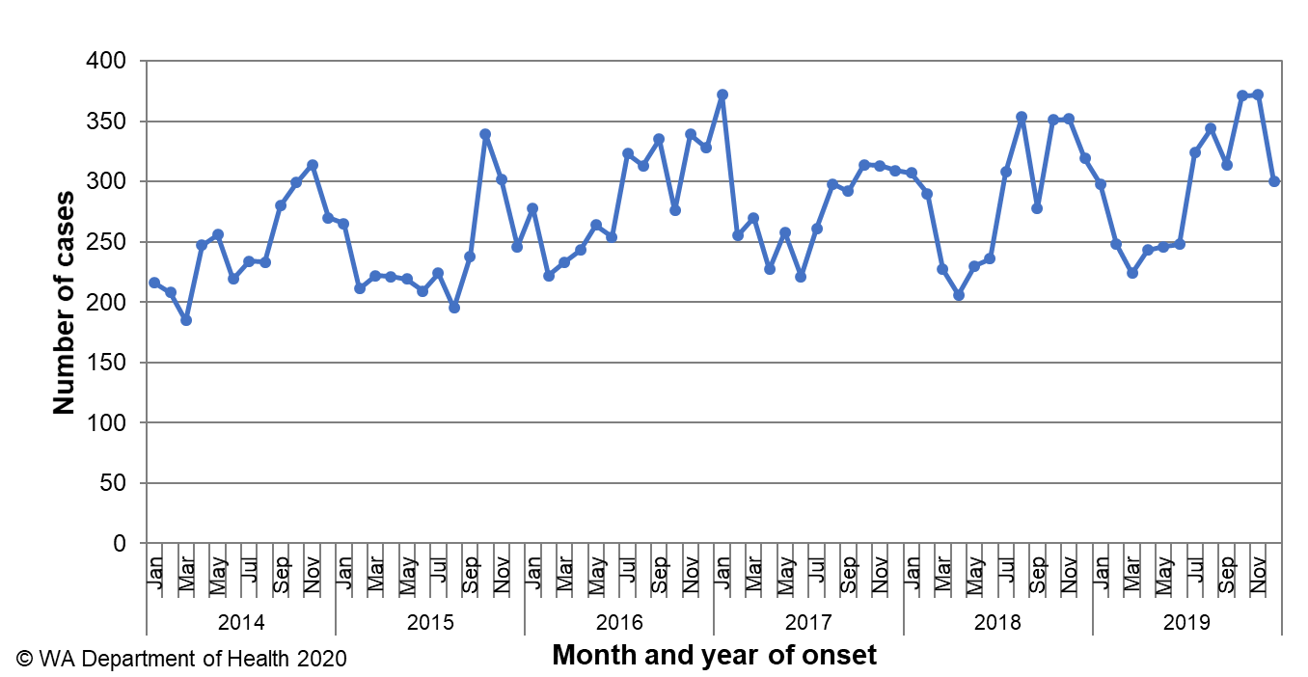

Figure 1 Number of notifications of campylobacteriosis by year and month of onset, WA, 2014 to 2019

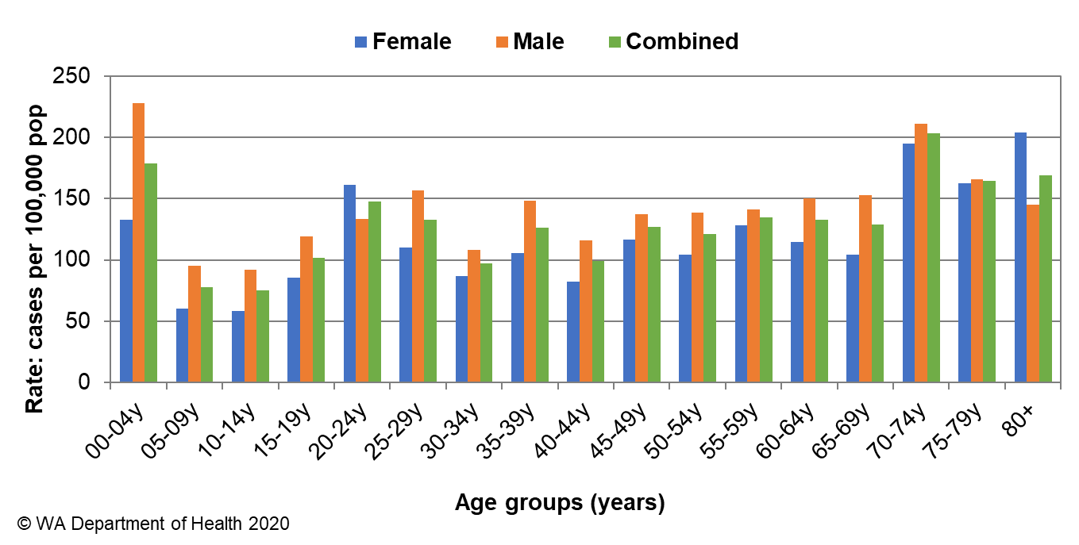

Figure 2 Age-specific notification rates for campylobacteriosis by sex, WA, 2019

For the last six years the notification rate for non-Aboriginal people has been consistently higher than for Aboriginal people and for 2019, the rate for non-Aboriginal people was 317% higher (219 and 69 per 100 000 population, respectively) (Figure 3). The 2019 notification rate for campylobacteriosis was highest in the STHW region (138 cases per 100 000 population). The regions with the lowest rate were the GOLD and MIDW (72 per 100 000 population) (Figure 4). Of those campylobacteriosis cases with known place of acquisition, most (74%) people acquired their illness in WA with 24% of people acquiring their illness overseas. Indonesia was the most common (68%) country of acquisition.

At least some of the increase in campylobacteriosis notifications is likely to be due to the use of PCR testing of faecal specimens by one large private pathology laboratory since 2014, and other private laboratories since 2016, which has greater sensitivity than culture techniques.

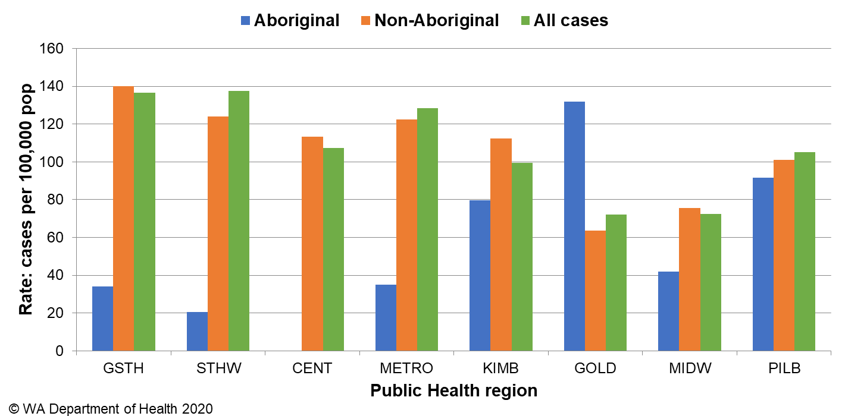

Figure 3 Campylobacteriosis notification rates by region and Aboriginality, WA, 2019

### Salmonellosis

Salmonellosis, which is an infection due to *Salmonella,* was the second most commonly notified enteric infection in WA in 2019, with 2154 cases (Appendix 1). The salmonellosis notification rate for 2019 was 76 cases per 100 000 population which is the second highest salmonellosis rate ever reported in WA (2017 being the highest at 95 per 100 000 population) and the second highest rate for 2019 among Australian jurisdictions ([NNDSS data](http://www9.health.gov.au/cda/source/rpt_4_sel.cfm)). The WA rate was 7% higher than the previous five-year average (71 cases per 100 000 population). Historically, salmonellosis notifications are highest in the summer months, with the peak for salmonellosis in 2019 noted in November (Figure 5).

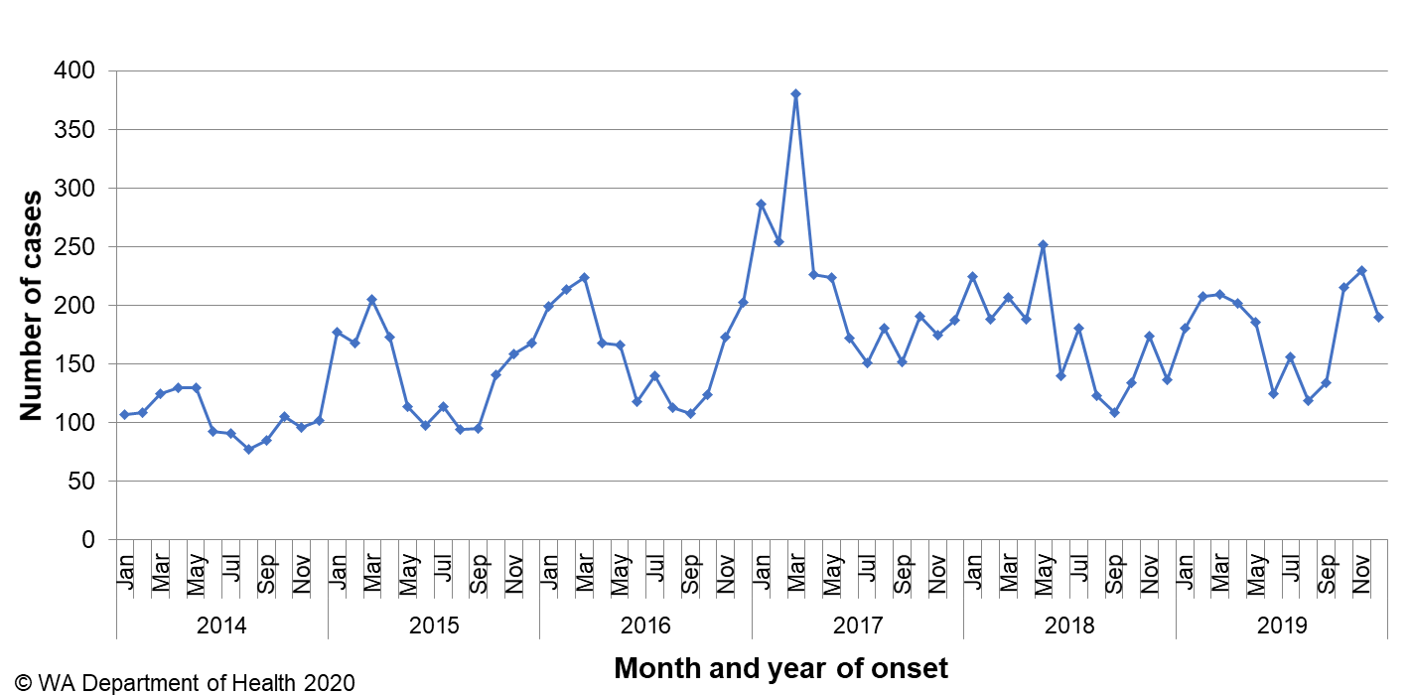

Figure 4 Number of notifications of salmonellosis by year and month of onset, WA, 2014 to 2019

The notification rates for females and males were almost the same (77 and 76 per 100 000 population, respectively). As in previous years, the 0-4 year age group had the highest notification rate (241 per 100 000 population) (Figure 6). The age groups 20-24 and 35-39 years, had the next highest notification rate (79 per 100 000 population).

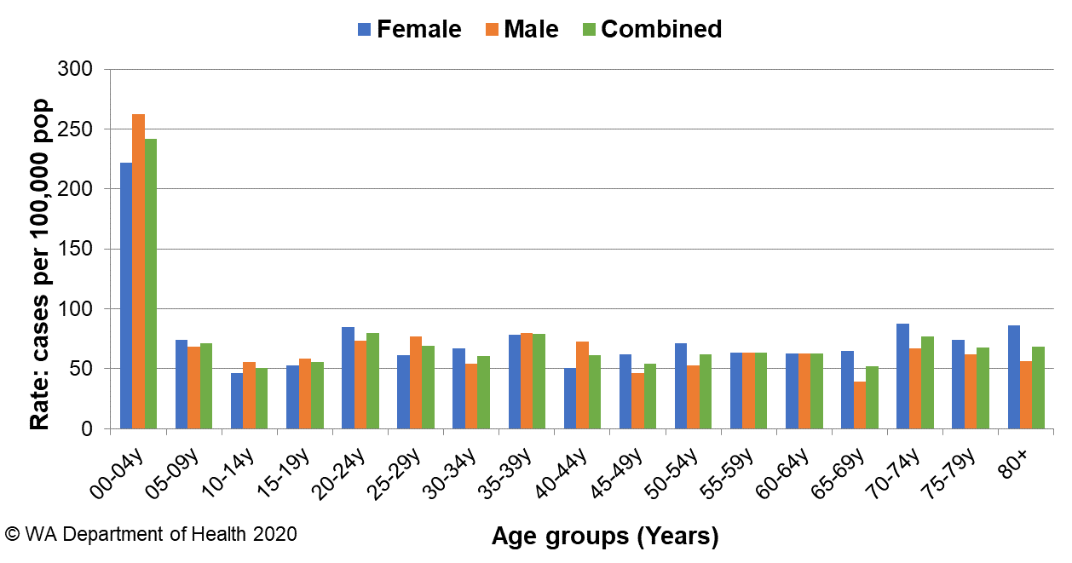

Figure 5 Age-specific notification rates for salmonellosis by sex, WA, 2019

The overall salmonellosis notification rate for Aboriginal people was 89 cases per 100 000 population, which was 1.21 times the notification rate for non-Aboriginal people, of 73 cases per 100 000 population.

The KIMB region had the highest notification rate in 2019 (154 per 100 000 population) which was 3.6 times the rate for the GSTH region, which had the lowest notification rate, of 43 cases per 100 000 population. The KIMB region had the highest notification rate for non-Aboriginal people when compared with other regions, while GOLD had the highest rate for Aboriginal people (Figure 7). These notifications in the KIMB region included a variety of serotypes and did not cluster in time or location. Of those salmonellosis cases with known place of acquisition (1663/2155, 77%), most (74%) people acquired their illness in WA with 25% of people acquiring their illness overseas (Figure 8). Indonesia was the most common (60%) country of acquisition.

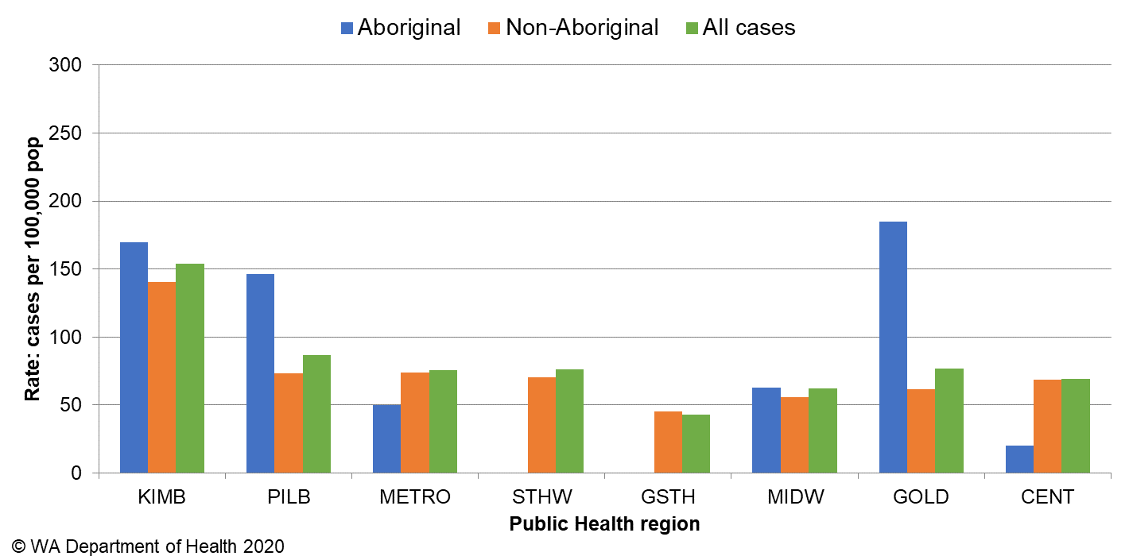

Figure 6 Salmonellosis notification rates by region and Aboriginality, WA, 2019

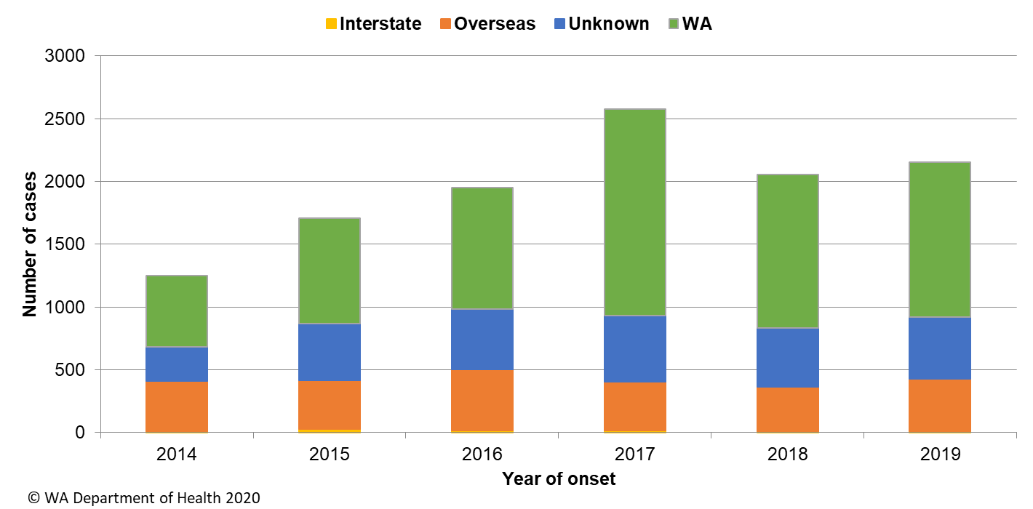

Figure 7 Salmonellosis notifications by place of acquisition, by year of onset, 2014 to 2019

The most commonly notified *Salmonella* serotype in WA in 2019 was *S.* Typhimurium (STM), with 1111 notifications (Table 1), which was 1.3-fold higher than the mean of the previous five years. STM is further typed using MLVA and there were 207 MLVA types identified in 2019. Of these, the top 10 types contributed 58% (n= 652) of the total STM notifications and the most common MLVA type (03-17-09-12-523) contributed 32% of all STM notifications (Table 2). MLVA type 03-17-09-12-523 was also the *Salmonella* type that caused eight of the 24 *Salmonella* outbreaks investigated in 2019 (see section 5.3). The next most common MLVA types were 03-10-17-11-496 (n=66), and 03-17-10-12-523 (n=49), which is closely related to the most common MLVA pattern. These MLVA types caused three and two outbreaks, respectively.

The second most commonly notified serotype was *S*. Enteritidis with 209 notifications, which was 2% above the mean of the previous five years (Table 1). In 2019, 94% (197/209) of cases with *S*. Enteritidis infection travelled overseas during their incubation period and of these cases, 68% (n=132) had travelled to Indonesia. There were 11 (5%) cases of *S*. Enteritidis that appeared to be locally acquired, but interviews of cases did not identify a common source.

Notifications of *S.* Muenchen were almost double the average of the previous five years (Table 1). The number of notifications increased through to July before decreasing and then peaking again in December. *S.* Muenchen affected residents in both metropolitan (n=20) and regional (n=22) areas. The increase in *S.* Muenchen cases in December was investigated but no epidemiological link between cases could be identified.

The increase in *Salmonella* species (where a species was not identified) was likely to be due to the introduction of PCR testing by some WA laboratories in 2014 and 2016. Some specimens are PCR-positive for *Salmonella* but culture-negative. A culture-positive result is required for the serotype to be determined.

Table 1 Number and proportion of the top 10 *Salmonella* serotypes notified in WA, 2019, with comparison to the 5-year average

*Percentage of total *Salmonella* cases notified in 2019.

‡Ratio of the number of reported cases in 2019 compared to the five-year mean of 2014-2018.

Table 2 The 10 most common *S*. Typhimurium MLVA types reported in 2019



*Sporadic cases are not identified as part of a source outbreak

^One outbreak included 4 notified cases of 03-17-09-12-523 and 1 notified case of 03-17-08-12-523

### Rotavirus infection

There were 540 cases of rotavirus infection in WA in 2019 (19.2 per 100 000 population), making rotavirus the third most commonly notified enteric infection. The notification rate in 2019 was 25% higher than the previous five-year average of 15.4 cases per 100 000 population (Appendix 1). Historically, rotavirus notifications typically peak in the winter months (Figure 9), with data from 2019 following this trend.

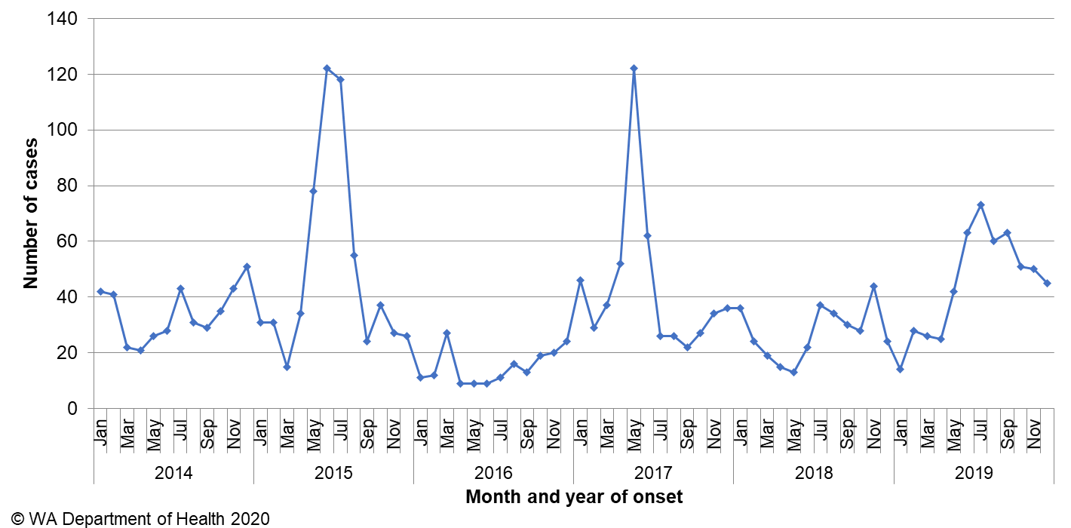

Figure 8 Number of notifications of rotavirus infection by year and month of onset, WA, 2014 to 2019

As in previous years, the age group with the highest rotavirus notification rate in 2019 was the 0-4 years group (146 cases per 100 000 population), followed by the 80+ year age group (33 cases per 100 000 population) (Figure 10). The overall notification rate was similar for females and males (21 and 18 per 100 000 population, respectively).

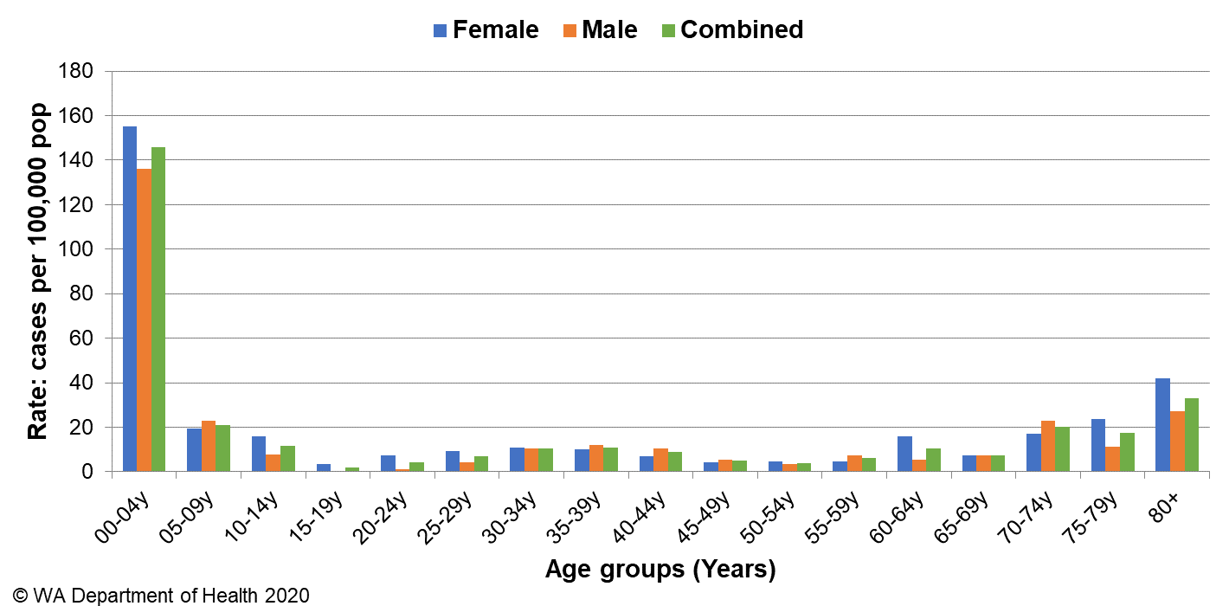

Figure 9 Age-specific notification rates for rotavirus by sex, WA, 2019

The regions with the highest rotavirus notification rates in 2019 were the MIDW, METRO and PILB regions (24, 20 and 17 cases per 100 000 population, respectively) (Figure 11). Overall, notification rates were 1.7 times higher for Aboriginal than for non-Aboriginal people (31 and 18 per 100 000 population, respectively). Of those rotavirus cases with known place of acquisition, most (93%) people acquired their illness in WA with 7% of people acquiring their illness overseas. There were three person-to-person outbreaks due to rotavirus in 2019, two in RCFs and one at a child care facility (Table 4).

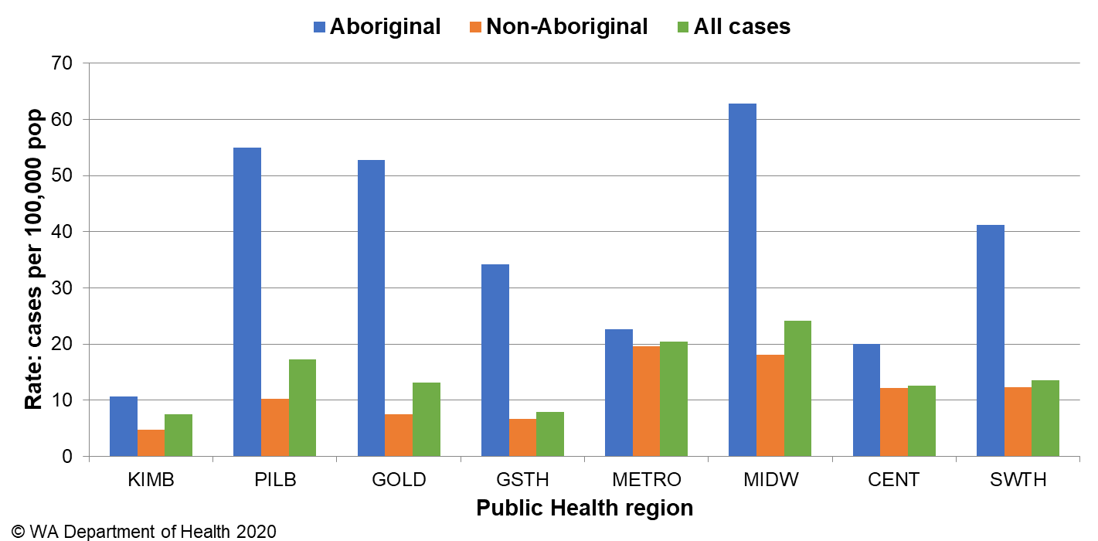

Figure 10 Rotavirus notification rates by region and Aboriginality, WA, 2019

### Shigellosis

As of 1 July 2018 the national *Shigella* case definition changed to include notifications that are PCR positive as probable cases and culture positive notifications as confirmed cases. In 2019 there were 218 probable shigellosis cases (7.7 cases per 100 000), these were all notified as *Shigella* species. Of the 218 probable cases, 93% (n=202) were for Metropolitan residents, and of those, 51% (n=104) were acquired overseas.

There were 171 confirmed cases of shigellosis notified in 2019, with a notification rate of 6.1 per 100 000 population. Of the 171 confirmed cases, 43% (n=74) were for Metropolitan residents, and of those, 43% (n=32) were acquired overseas.

Overall, the 2019 notification rate for shigellosis was 13.8 per 100 000 population, which is 2.6-fold higher than the previous five-year average (Appendix 1). The number of notifications was highest in January 2019 (Figure 12).

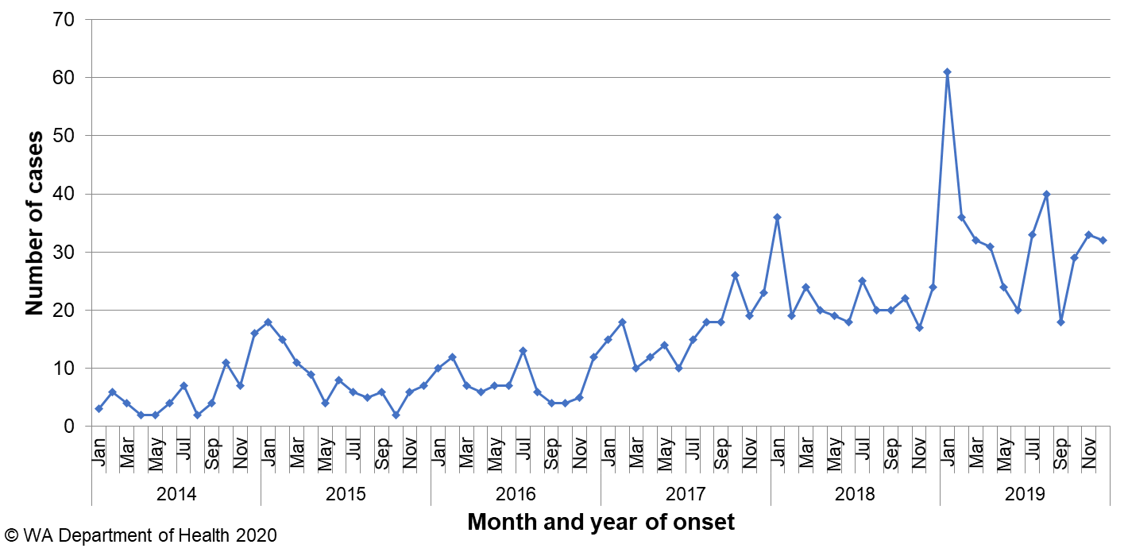

Figure 11 Number of notifications of shigellosis by year and month of onset, WA, 2014 to 2019. Probable and confirmed cases are included

The shigellosis notification rate was 13% higher in males compared to females in 2019 (14.6 and 13.0 per 100 000 population, respectively). The 0-4 years age group had the highest rate of notification with 31 cases per 100 000 population (Figure 13). The PHU with the highest shigellosis notification rate was KIMB (109 cases per 100 000 population) followed by GOLD and MIDW (46 cases per 100 000 population and 21 cases per 100 000 population, respectively) (Figure 14).

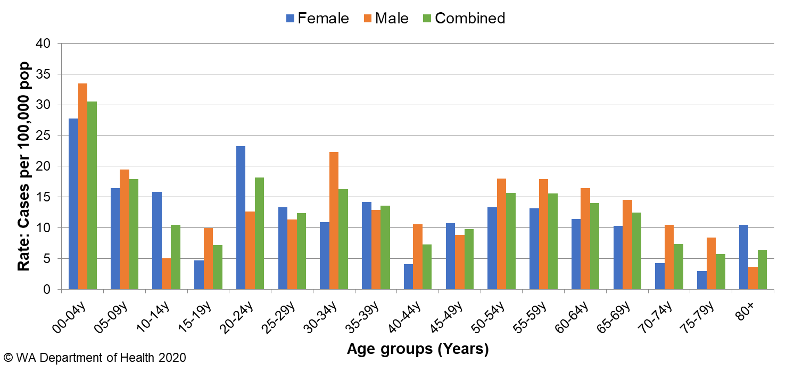

Figure 12 Age-specific notification rates for shigellosis by sex, WA, 2019

In 2019, the notification rate was 10 times higher for the Aboriginal population as compared to the non-Aboriginal population (102 and 10 per 100 000 population, respectively).

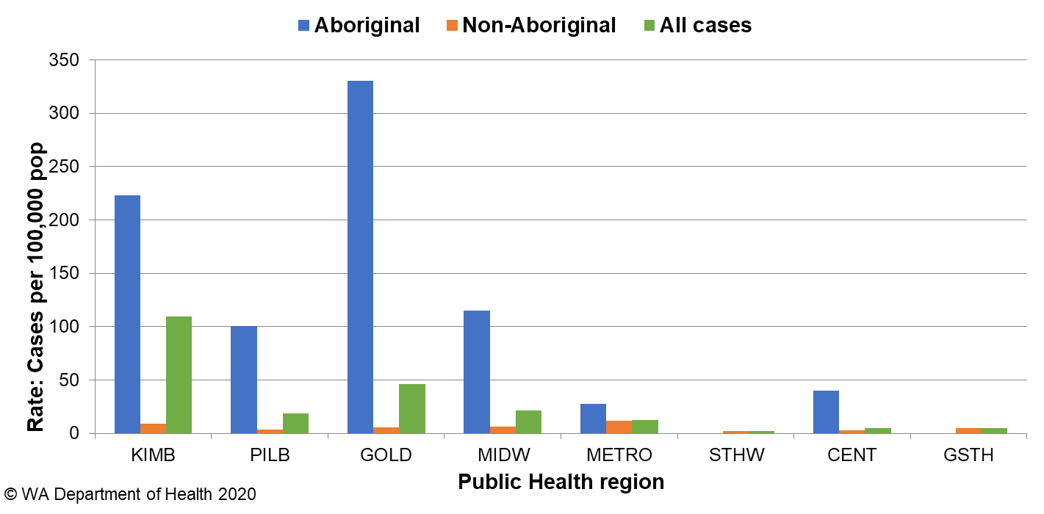

Figure 13 Shigellosis notification rates by region and Aboriginality, WA, 2019

The predominant subtypes of *Shigella* notified in 2019 were *S. flexneri* 2b (n=74) which peaked in January, *S. flexneri* 2a (n=31) which peaked in November and had small numbers of notifications reported throughout the year, and then *S. sonnei* biotype G (n=28) which peaked in December and also had small numbers of notifications reported throughout the year (Figure 15). *S. flexneri* 2b notifications were 35% higher than the five-year average of 55 notifications. Of the notifications with known travel history, 100% *S. flexneri* 2b were locally acquired and 88% were in Aboriginal people. *S. flexneri* 2a notifications were 417% higher than the five-year average, with a 4% increase in *S. sonnei* biotype G. For *S. flexneri* 2a of those with travel history, 82% were locally acquired and 61% were in Aboriginal people; of the 64% of *S. sonnei* biotype G with travel history, 72% cases had travelled overseas and all cases, where indigenous status was known, were non-Aboriginal people. *S. sonnei* biotype G was 15% higher in males (n=15) than females (n=13).

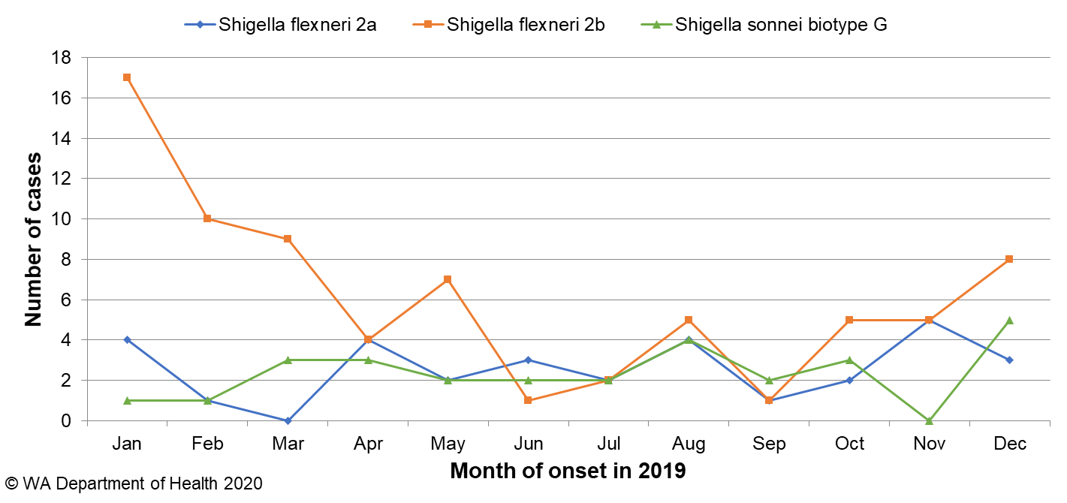

Figure 14 The three most common *Shigella* types notified in 2019

### Cryptosporidiosis

There were 211 cryptosporidiosis cases notified in 2019, which was the fifth most common notifiable enteric disease. The notification rate (7 cases per 100 000 population) was 26% lower than the mean of the previous five years (10.1 cases per 100 000 population) (Appendix 1). In each of the years from 2014 to 2019, the number of cryptosporidiosis notifications was higher in the late summer through to autumn (Figure 16). In 2019, there was also a noticeable increase in cases from late spring, this was largely attributed to an animal-to-person outbreak in the STHW region (section 5.2).

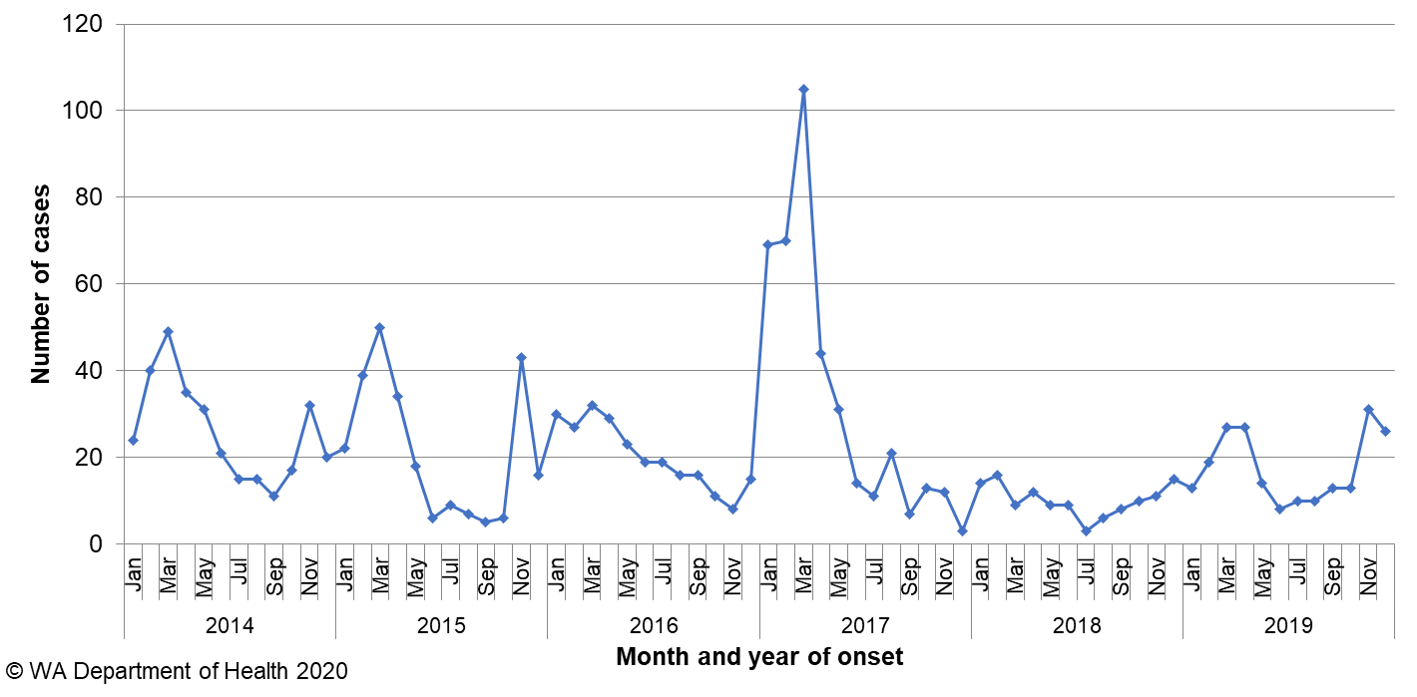

Figure 15 Number of notifications of cryptosporidiosis by year and month of onset, WA, 2014 to 2019

The cryptosporidiosis notification rate in females was 31% higher than males in 2019 (8.5 and 6.5 per 100 000 population, respectively). The 0-4 years age group had the highest notification rate (39 per 100 000 population), and accounted for 36% of all cryptosporidiosis notifications (Figure 17). 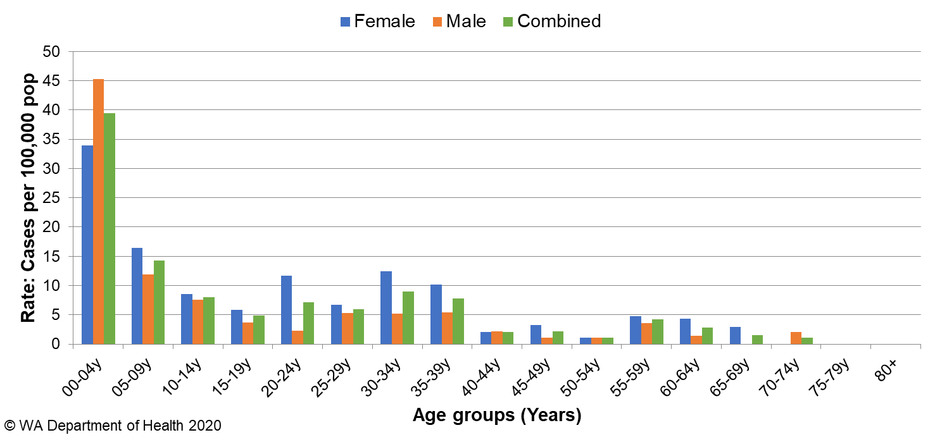

Figure 16 Age-specific notification rates for cryptosporidiosis by sex, WA, 2019

The overall notification rate for the Aboriginal population was 1.7 times the rate for the non-Aboriginal population (19 and 11 cases per 100 000 population, respectively). The KIMB region had the highest notification rate (89 cases per 100 000 population), followed by the PILB region (20 cases per 100 000 population) (Figure 18). Of those cryptosporidiosis cases with known place of acquisition, most (78%) people acquired their illness in WA, with 21% of people acquiring their illness overseas and 1% of people acquiring their illness interstate.

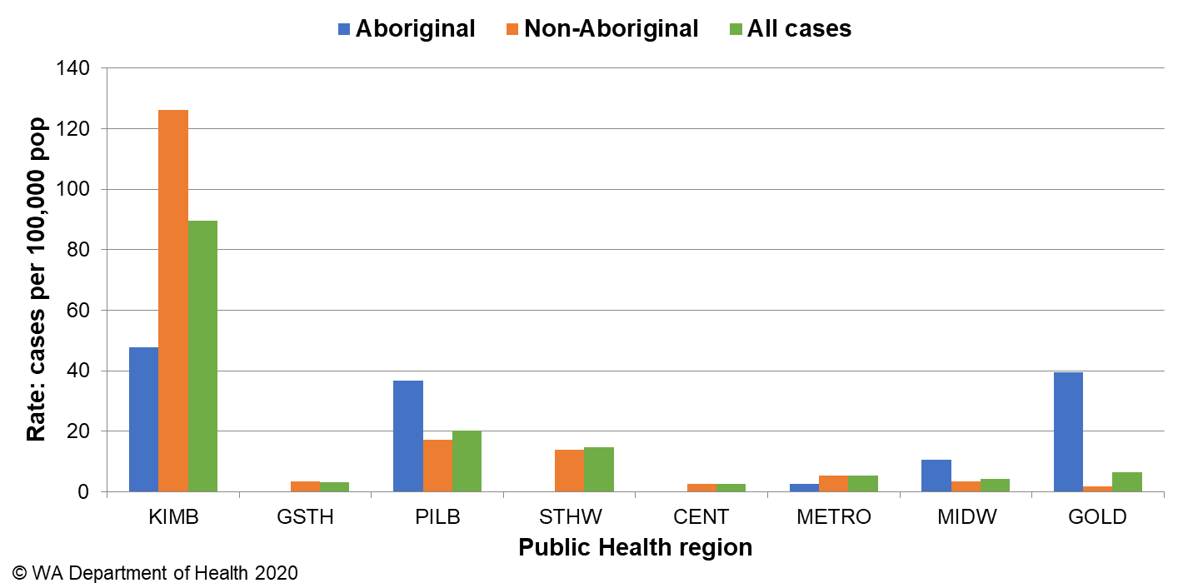

Figure 17 Cryptosporidiosis notification rates by region and Aboriginality, WA, 2019

### Shiga toxin-producing *E. coli* (STEC)infection

There were 151 cases of STEC reported in 2019 with a rate of 5 cases per 100 000 population, which was 2.9-fold higher than the five-year average. The large increase in 2019 compared to previous years is likely to be due to the introduction of PCR tests for STEC by two pathology laboratories, which also notified all STEC cases in WA for 2019. One of these laboratories uses a PCR test on faecal specimens with bloody diarrhoea, by request or signs of HUS and began using this method in January 2016. Another laboratory also introduced a PCR test for STEC on request in July 2016, this changed in December 2018 to include PCR testing on all stool specimens. Of the 151 cases, 137 were followed up and 94 (67%) had an acute illness prior to testing. The remaining cases had chronic gastroenteritis symptoms or no symptoms. Culture was performed on 112 specimens, of which 68 (61%) were culture-positive. Serotypes included O157:H7 (n=18), O128:H2 (n=17), O26:H11 (n=6), O111:H8 (n=3), O91:H14 (n=3), and two each of O103:H2, O113:H21, OGp8:H7 and Ont:H7. Remaining isolates were all unique serotypes. Of the 151 cases, 61 (40%) were male and 90 (60%) were female with a median age of 37 years (range 0-95 years). Of those cases with an acute illness and with a known travel history, 62 (66%) had acquired their infection in WA and 31 (34%) had acquired their infection overseas. Overseas cases were predominantly from Indonesia (n=16), Vietnam (n=3) and Thailand (n=2). Of locally acquired cases interviewed, no point source outbreaks or clusters were identified.

### Hepatitis A infection

There were 24 cases of hepatitis A notified in 2019 with a rate of 0.9 cases per 100 000 population, which was a 32% increase from the average rate of the previous five years (Appendix 1).

The age range for the 2019 cases was 1 to 68 years (median age 13 years), with 11 (46%) male and 13 (54%) female notifications. The majority (n=17, 71%) of notifications in 2019 were acquired overseas (Figure 19).

Seven cases were locally acquired, with three epidemiologically-linked to another confirmed case and three from the same household with no known risk factors. The remaining locally acquired case had no known risk factors.

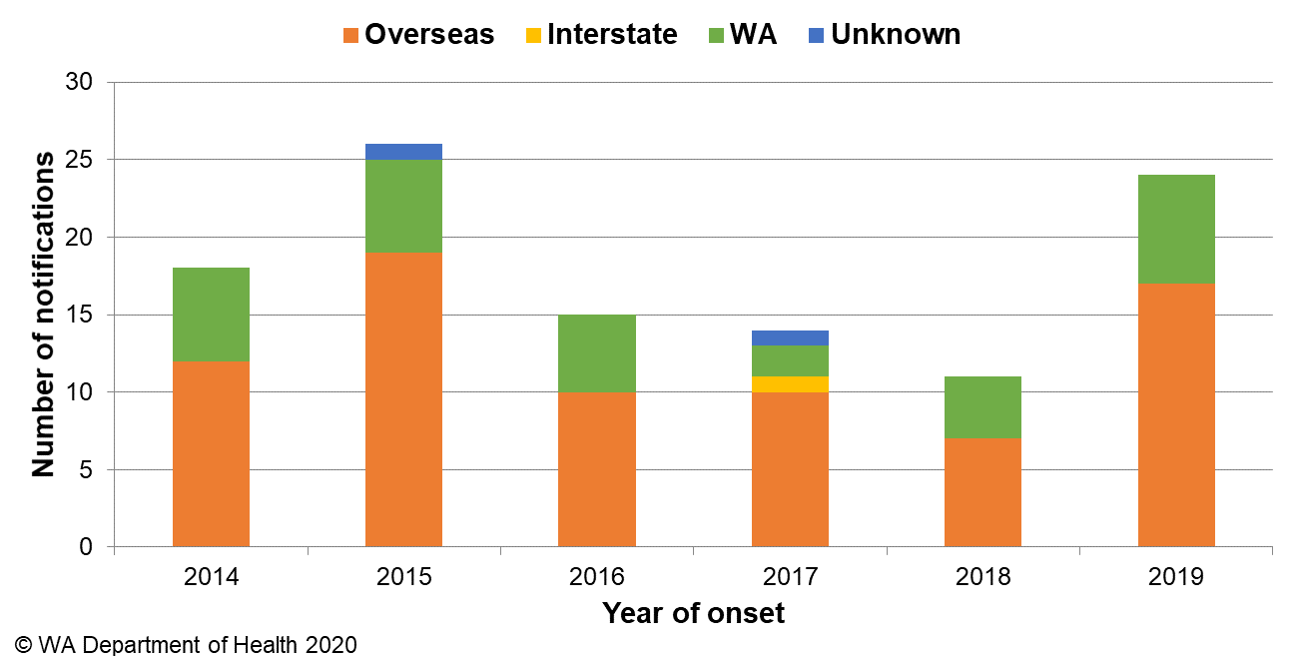

Figure 18 Place of acquisition for hepatitis A notifications, 2014 to 2019

### *Yersinia* infection

There were 22 cases of culture-positive *Yersinia* *enterocolitica* infection notified in 2019, with a rate of 0.8 cases per 100 000 population, which is a 36% increase compared to the mean rate of the previous five years (Appendix 1). There were nine female and 13 male cases with ages ranging between 1 and 78 years. Thirteen cases had acquired their illness in WA, two cases acquired their illness overseas in Sri Lanka (n=1) and the United States of America (n=1), and the place of acquisition was unknown for seven cases. The majority (n=20) of cases were notified by one private pathology laboratory, which uses a faecal PCR screening test with reflex culture. Eleven cases were investigated as part of a cluster (Section 5.3), no hypothesis as to the cause of illness could be established.

### Typhoid and paratyphoid fever

In 2019, there were 20 cases of typhoid fever (caused by *Salmonella* Typhi) notified with a rate of 0.7 cases per 100 000 population, which is similar to the average rate of the previous five years (Appendix 1). All cases had recently travelled overseas prior to illness onset and countries included India (n=17), Pakistan (n=1), Zimbabwe (n=1) and Fiji (n=1). Nine cases of paratyphoid fever were notified in 2019 with a rate of 0.3 cases per 100 000 population, which was 8% lower than the mean rate of the previous five years (Appendix 1). All nine paratyphoid fever cases were *S*. ParatyphiA; all had overseas acquisition, and countries included India (n=7), Bangladesh (n=1) and Indonesia (n=1).

### *Vibrio parahaemolyticus* infection

There were 16 cases of *Vibrio parahaemolyticus* infection notified in 2019 with a rate of 0.6 cases per 100 000 population which was on par with the mean rate of the previous five years (Appendix 1). These included 10 male and six female cases, ranging in age from five to 68 years. Of these cases, eight reported travel overseas during their incubation period (Vietnam n=3, Indonesia n=3, Cambodia n=1, Malaysia n=1) and eight acquired their illness in WA. Two locally acquired cases were investigated as part of a cluster (Section 5.3), both were found to have eaten oysters. These two cases coincided with cases in SA and TAS who had also eaten oysters but due to issues with traceback no common link was identified. Of the six remaining locally acquired cases in WA, two were detected via stool samples and four via wound swabs.

### Listeriosis

There were seven cases of *Listeria monocytogenes* infection notified in 2019 with a rate of 0.2 cases per 100 000 population, which was 7% higher than the average rate of the previous five years (Appendix 1). Four cases were pregnancy-related, including one materno-foetal pair (Figure 20). The remaining three had immunocompromising illnesses. Cases ranged in age from 0 to 55 years, with three males and four female cases. One foetal death was reported as a result of infection. Two locally acquired cases were investigated as part of a cluster (Section 5.3).

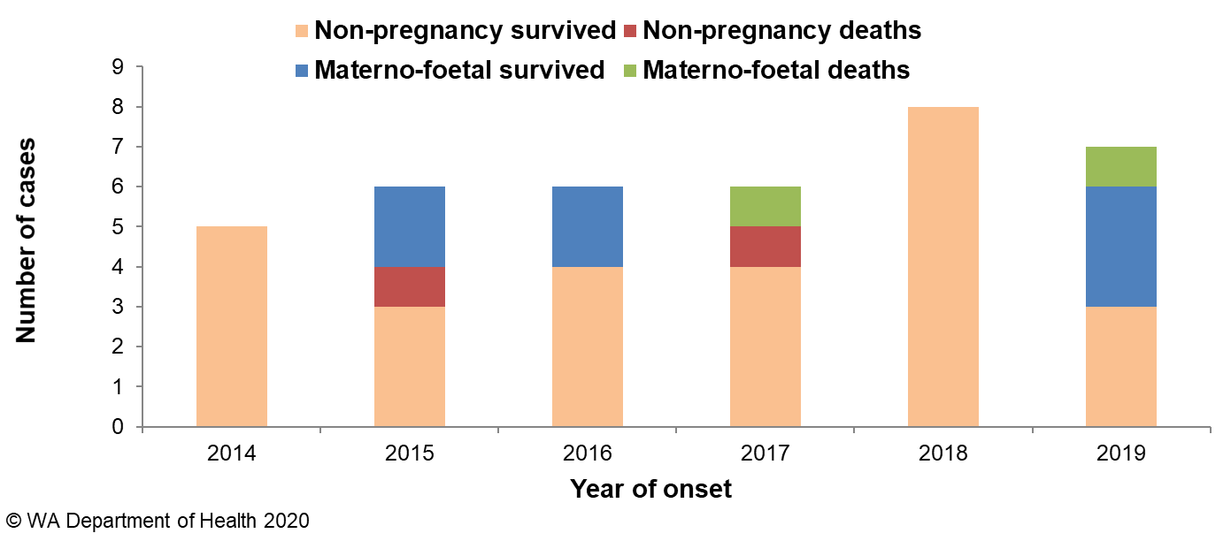

Figure 19 Notifications of listeriosis showing non-pregnancy related infections and deaths, and materno-foetal infections and deaths, WA, 2014 to 2019

### Hepatitis E infection

There were four cases of hepatitis E notified in 2019. One case was male and three were female, aged eight to 63 years. Two cases had travelled to Pakistan (n=1) and India (n=1). The other two cases had no travel or known risk factors.

### Haemolytic Uraemic Syndrome (HUS)

One case of HUS was notified in 2019 in a female aged 12 years. The case did report a gastrointestinal illness with diarrhoea and vomiting prior to the onset of HUS but no specimen was collected. The main risk factor identified was the case resided on a rural property and had contact with farm animals. One parent had also reported ongoing bloody diarrhoeal symptoms for over a month, but stool specimens collected were negative.

### Cholera

There were no cases of cholera notified in WA in 2019.

### Botulism

There were no cases of botulism notified in WA in 2019.

# Gastrointestinal disease outbreaks and investigations

### Foodborne and probable foodborne outbreaks

There were 26 foodborne or probable foodborne gastroenteritis outbreaks investigated in WA in 2019 (Table 3). The number of foodborne and probable foodborne outbreaks was almost equal to the five-year average (n=25) but had decreased compared to 2017 and 2018 which had 42 and 37 outbreaks, respectively. The 26 foodborne outbreaks caused at least 472 cases of gastroenteritis and 53 hospitalisations. Short descriptions of these outbreaks are provided in [2019 quarterly reports](http://ww2.health.wa.gov.au/Articles/F_I/Infectious-disease-data/Enteric-infection-reports-and-publications-OzFoodNet).

**Aetiology**

Of the 26 outbreaks, 23 were due to STM, with eight outbreaks of MLVA type 03-17-09-12-523, two outbreaks each of MLVA type 03-17-10-12-523, MLVA type 03-18-09-12-523, and MLVA type 03-10-17-11-496 and nine outbreaks of unique MLVA types. This was an almost 1.2-fold increase in STM outbreaks compared to the five-year average (n=18.8) but lower than the last two years. For the remaining three outbreaks, two outbreaks were due to norovirus and one was caused by *Salmonella* Paratyphi B bv Java.

**Food vehicles**

The investigations of the 26 outbreaks identified food vehicles for 13 outbreaks. Of these, nine (69%) were associated with eating egg dishes. This was a decrease in egg dishes compared to the five-year average (n=10). Egg dishes included raw egg mayonnaise/aioli, breakfast egg dishes, custard doughnuts, French toast, amaretto sours, Vietnamese pork rolls and sushi, which both contained a raw egg mayonnaise. All nine egg-related outbreaks were caused by STM, including MLVA types 03-17-09-12-523 (n=2), and one each of 03-10-16-11-496, 03-10-17-11-496, 03-11-15-10-523, 03-12-11-10-523, 03-17-10-12-523, 03-17-10-15-523 and 03-18-08-12-523. The egg producer and production system was able to be determined in seven of these nine egg-related outbreaks and included multiple egg producers, and free-range and cage production systems. This information was gathered from environmental investigations. This finding should be interpreted with caution regarding market share and multiple factors associated with the handling of eggs and egg-based products can contribute to whether an egg dish causes an infection. The norovirus outbreaks were due to chicken salad and sandwiches/ Turkish wraps and the *Salmonella* Paratyphi B bv Java outbreak was associated with a chocolate mint cheesecake with no one ingredient identified as the source.

**Epidemiological investigation and evidence**

The evidence that supported the classification of 26 enteric outbreaks as foodborne or probable foodborne transmission was obtained using analytical studies for four outbreaks, microbiology for one outbreak, and descriptive case studies (DCSs) for 21 outbreaks. The analytical studies involved interviewing those people who were at the implicated meal using a questionnaire on all foods/drinks available. These studies can be used to find a statistical association between a food eaten and illness, and in 2019 an association was found in four outbreaks. Microbiological evidence refers to the implicated food being positive for the same pathogen as the cases. For the outbreaks investigated as a DCS, there was strong circumstantial evidence to support probable foodborne transmission, such as independently visiting a common food business, or the venue being the only source of food for cases.

**Food preparation settings**

The setting where food was prepared for the 26 foodborne outbreaks in 2019 included 16 restaurants (caused by STM n=15, *S*. Paratyphi B bv Java n=1), two hospitals (both caused by STM), two mining camps (both caused by STM), two commercial caterers (both caused by norovirus), and one outbreak each in a prison (STM), private residence (STM), grocery store (STM) and a bakery (STM).

Table 3 Foodborne and probable foodborne outbreaks, 2019

|  |  |  |  |  |  |  |  |  |  |  |
| --- | --- | --- | --- | --- | --- | --- | --- | --- | --- | --- |
| **Mode of transmission** | **Outbreak code** | **Month of outbreak1** | **Where food prepared** | **Where food eaten** | **Agent responsible2** | **Number ill** | **Hospitalised** | **Died** | **Evidence3** | **Responsible vehicles** |
| probable foodborne | 042-2019-001 | Jan | private residence | private residence | Salmonella Typhimurium MLVA 03-12-14-09-523 | 8 | 1 | 0 | D | unknown |
| probable foodborne | 042-2019-002 | Feb | restaurant | restaurant | Salmonella Typhimurium MLVA 03-17-09-12-523 | 10 | 3 | 0 | D | egg dish; aioli and arametto sours |
| probable foodborne | 042-2019-003 | Feb | restaurant | restaurant | Salmonella Typhimurium MLVA 03-19-10-12-523 | 27 | 6 | 0 | M | unknown |
| probable foodborne | 042-2019-004 | Feb | hospital | hospital | Salmonella Typhimurium MLVA 03-13-11-10-523 | 2 | 0 | 0 | D | unknown |
| probable foodborne | 042-2019-005 | Feb | restaurant | restaurant | Salmonella Typhimurium MLVA 03-17-09-12-523 | 5 | 0 | 0 | D | unknown |
| probable foodborne | 042-2019-006 | Feb | restaurant | restaurant | Salmonella Para B bv Java | 8 | 1 | 0 | D | chocolate mint cheesecake |
| probable foodborne | 042-2019-007 | Mar | restaurant | restaurant | Salmonella Typhimurium MLVA 03-12-11-10-523 | 15 | 3 | 0 | D | egg dish: doughnuts and breakfast eggs |
| probable foodborne | 042-2019-008 | Mar | restaurant | restaurant | Salmonella Typhimurium MLVA 03-18-09-12-523 | 7 | 2 | 0 | D | unknown |
| foodborne | 042-2019-009 | Mar | other | other | Salmonella Typhimurium MLVA 03-17-10-12-523 x29; MLVA 03-16-10-12-523 x1 | 49 | 9 | 0 | A | egg dish; breakfast egg dishes |
| probable foodborne | 042-2019-010 | Apr | hospital | hospital | Salmonella Typhimurium MLVA 03-17-09-12-523 | 2 | 0 | 0 | D | unknown |
| probable foodborne | 042-2019-011 | Apr | restaurant | restaurant | Salmonella Typhimurium MLVA 03-10-16-11-496 | 9 | 0 | 0 | D | egg dish; sushi rolls with raw egg mayonnaise |
| foodborne | 042-2019-012 | Apr | restaurant | function | Salmonella Typhimurium MLVA 03-17-09-12-523 x 10; MLVA 03-17-08-12-523 x 1 | 44 | 5 | 0 | A | seafood paella |
| probable foodborne | 042-2019-013 | May | restaurant | restaurant | Salmonella Typhimurium MLVA 03-10-17-11-496 | 13 | 1 | 0 | D | unknown |
| probable foodborne | 042-2019-014 | May | institution | institution | Salmonella Typhimurium MLVA 03-11-15-10-523 | 4 | 1 | 0 | D | egg dish; French toast |
| probable foodborne | 042-2019-015 | Jun | other | other | Salmonella Typhimurium MLVA 03-17-09-12-523 | 2 | 0 | 0 | D | unknown |
| probable foodborne | 08/19/TCS | Aug | commercial caterer | other | Norovirus | 81 | 1 | 0 | A | sandwiches & Turkish wraps |
| probable foodborne | 042-2019-016 | Sep | restaurant | restaurant | Salmonella Typhimurium MLVA 03-17-09-12-523 | 2 | 1 | 0 | D | unknown |
| probable foodborne | 042-2019-017 | Oct | grocery store/delicatessen | private residence | Salmonella Typhimurium MLVA 03-25-17-12-523 | 8 | 2 | 0 | D | unknown |
| foodborne | 042-2019-018 | Oct | restaurant | restaurant | Salmonella Typhimurium MLVA 03-17-09-12-523 | 37 | 9 | 0 | M | egg dish; raw egg mayonnaise |
| probable foodborne | 042-2019-020 | Nov | restaurant | restaurant | Salmonella Typhimurium MLVA 03-10-17-11-496 | 12 | 0 | 0 | D | egg dish: aioli |
| probable foodborne | 042-2019-021 | Nov | restaurant | restaurant | Salmonella Typhimurium MLVA 03-17-10-15-523 | 13 | 1 | 0 | D | egg dish; breakfast egg dishes |
| probable foodborne | 042-2019-022 | Dec | bakery | community | Salmonella Typhimurium MLVA 03-17-10-12-523 | 4 | 0 | 0 | D | unknown |
| probable foodborne | 042-2019-023 | Dec | restaurant | restaurant | Salmonella Typhimurium MLVA 03-18-09-12-523 | 3 | 0 | 0 | D | unknown |
| probable foodborne | 042-2019-024 | Dec | restaurant | community | Salmonella Typhimurium MLVA 03-18-08-12-523 | 14 | 3 | 0 | D | egg dish; Vietnamese pork rolls with raw egg mayonnaise |
| probable foodborne | 042-2019-025 | Dec | restaurant | restaurant | Salmonella Typhimurium MLVA 03-17-09-12-523 | 9 | 2 | 0 | D | unknown |
| probable foodborne | 12/19/WAP | Dec | commercial caterer | commercial caterer | Norovirus | 84 | 2 | 0 | A | chicken salad |

**1**Month of outbreak is the month the outbreak was first reported or investigated, whichever is earliest

2MLVA=multi-locus variable number tandem repeat analysis

3D = descriptive, M= microbiological, A=Analytical

### Outbreaks due to non-foodborne transmission or with an unknown mode of transmission

In 2019, there were 149 outbreaks of gastroenteritis investigated that were not classified as foodborne disease outbreaks (Table 4). These outbreaks included 129 outbreaks associated with person-to-person transmission, 18 outbreaks where the mode of transmission was unclear or unknown and one outbreak each due to probable waterborne and animal-to-person transmission (Figure 20).

**Probable person-to-person outbreaks**

Of the 129 probable person-to-person (PTP) transmission outbreaks, 69 (53%) occurred in RCFs, 46 (36%) in child care centres, nine (7%) in hospitals, four in schools (3%), and one (1%) on a cruise ship (Table 4). The causative agent for 48 (37%) of the outbreaks was confirmed as norovirus, three (2%) outbreaks were due to rotavirus and one outbreak each for adenovirus and sapovirus (1% each). In the remaining 76 (59%) outbreaks the causative agent was unknown, either because a pathogen was not identified during testing, specimens were not collected, viral testing was not requested, or it was not clear from the results what the causative pathogen was. A total of 2191 people were affected by these outbreaks, with 43 hospitalisations and 13 associated deaths.

The number of PTP outbreaks in 2019 was 2% lower than the average of the previous five years (n=121). Notably the number of outbreaks of child care outbreaks were higher than the previous five years (n=31) and outbreaks peaked in December (Figure 20).

**Outbreaks with unknown mode of transmission**

In the 18 outbreaks where the likely mode of transmission was unclear or unknown, 14 (78%) occurred in aged care facilities and two each were reported in child care and hospitals (Table 4).

In these outbreaks all cases had diarrhoea and the proportion of cases with vomiting ranged from 0-14%. These symptoms are not typical of viral gastroenteritis, particularly norovirus, outbreaks and therefore the outbreaks were described as unknown rather than person-to-person. Eleven out of 18 outbreaks had specimens tested which were negative for common bacterial and viral pathogens (including norovirus). No specimens were tested for four outbreaks.

Three outbreaks had positive results from specimens collected but the mode of transmission remained unclear. One outbreak had one specimen positive *for Blastocystis hominis* which was not suspected to be the cause of the outbreak. A second outbreak at a hospital involved three patients positive for *Salmonella* Anatum but there was insufficient evidence to suggest infection was due to foodborne transmission. The third outbreak at an aged care identified two pathogens, STM MLVA 03-17-09-12-523 and *Campylobacter* sp. In this outbreak it was suspected that two modes of transmission occurred. The most likely source of the *Campylobacter* infection was contact with chickens at the facility and the most likely source of the STM was egg consumption. However, as there is no definitive information on whether affected residents had contact with the chickens and there is no evidence of undercooked eggs being served at the facility, the source of infection remains unknown.

**Probable waterborne outbreaks**

There was one *Cryptosporidium* outbreak in 2019 that was likely caused by exposure to a local aquatic facility.

**Animal-to-person outbreaks**

There was one *Cryptosporidium* outbreak in 2019 that was associated with exposure to a petting zoo at a local agricultural show.

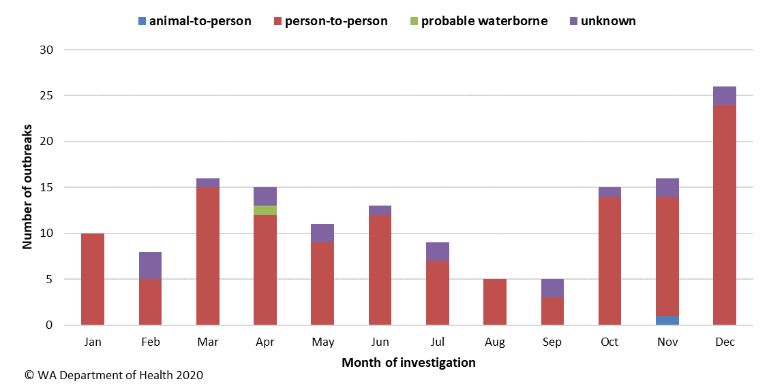

**Figure 20 Number of non-foodborne gastroenteritis outbreaks by mode of transmission and month, 2019**

**Table 4 Outbreaks due to non-foodborne transmission or unknown mode of transmission in WA by setting and agent, 2019**



1Deaths temporally associated with gastroenteritis, but contribution to death not specified

### Cluster investigations

In 2019, there were eight *Salmonella* clusters, three *Cryptosporidium* clusters and one cluster each of *Listeria*, *Vibrio parahaemolyticus* and *Yersinia* (Table 5).

**Significant clusters  
*Salmonella* Typhimurium MLVA 03-17-09-12-523**

Up until September 2016, STM MLVA 03-17-09-12-523 had not been notified in WA since MLVA typing began in WA in January 2015. There were 78 cases of this MLVA type in 2016, starting with a single case in September, then 610 cases in 2017, 421 cases in 2018 and 365 in 2019 (Figure 21). In 2019, 66 cases were related to outbreaks and eight point source outbreaks were investigated (Table 2). The 299 community cases comprised 44% males and 56% females, ranged in age from 0 to 90 years (median 28 years), and most (86%) resided in the Perth metropolitan area. Hospitalisation data was known for 285 community cases; 30% were hospitalised. Interviews regarding exposures were conducted for 237 cases.

Eggs or egg-containing dishes were implicated in two point source outbreaks of STM MLVA 03-17-09-12-523 in 2019. One egg producer was implicated in both outbreaks. This producer was also identified at the premises during inspection in five out of the six remaining outbreaks of this MLVA type in 2019 where the food vehicle was reported as unknown, or cross contamination issues were suspected. Additionally, this producer has been implicated in previous outbreaks of this MLVA type. In the last remaining outbreak, a third egg producer was identified which has also been implicated in previous outbreaks of this MLVA type however it was uncertain if these were the eggs used at the time of outbreak.

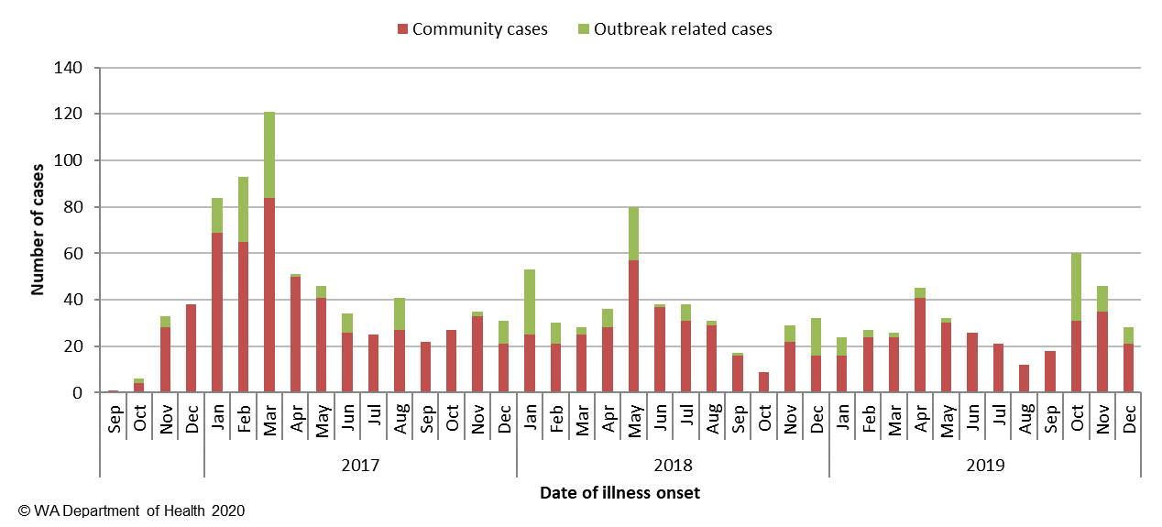

Figure 21 Notifications of *Salmonella* Typhimurium MLVA 03-17-09-12-523 in WA

From emergence of this strain in September 2016 to end of 2019, there have been 1474 cases, 393 hospitalisations and 6 deaths temporally associated with this infection in WA. This increase appears to be isolated to WA. A total of 43 point source outbreaks with this strain have been investigated since 2016, of which 20 were linked to consumption of raw or undercooked eggs.

In response to this ongoing investigation a *Salmonella* Outbreak Response Taskforce was established in July 2019 which included representatives from Department of Health, PathWest laboratory, Department of Primary Industry and Regional Development, and select Local Governments. The primary outcomes of the taskforce were to collaborate with egg producers which would include on-farm testing and recommendations of epidemiologically implicated farms, undertake a retail egg study to determine the level of *Salmonella* contamination on eggs in WA and to further analyse a selection of isolates, both human and non-human, related to this ongoing investigation by whole genome sequencing (WGS) at PathWest. All projects are currently ongoing. Of WGS completed to date, all were found to be closely related, which supported the hypothesis that illness is likely due to a common exposure or exposure to products with a common source of contamination.

**Table 5 Cluster investigations in WA by month investigation started, setting and agent, 2019**



*MLVA=multi-locus variable number tandem repeat analysis

# References

1. Hall G, Kirk MD, Becker N, Gregory JE, Unicomb L, Millard G, et al. Estimating foodborne gastroenteritis, Australia. Emerg Infect Dis 2005;11(8):1257-1264.
2. OzFoodNet Working Group. A health network to enhance the surveillance of foodborne diseases in Australia. Australian Government Department of Health 2017. <https://www1.health.gov.au/internet/main/publishing.nsf/Content/cdna-ozfoodnet.htm>
3. Western Australian Department of Health. A-Z list of case definitions. Western Australian Department of Health 2019. <http://ww2.health.wa.gov.au/Articles/N_R/Notification-of-infectious-diseases-and-related-conditions>.
4. Australian national notifiable diseases and case definitions. Australian Government Department of Health 2018

<http://www.health.gov.au/casedefinitions>

1. Western Australian Department of Health. Contact details for regional population / public health units. Western Australian Department of Health 2018. <http://healthywa.wa.gov.au/Articles/A_E/Contact-details-for-population-public-health-units>.

# Appendix 1: Number of notifications, notification rate2 and ratio of current to historical mean by pathogen/condition, 2014 to 2019, WA



1Abbreviations: STEC: Shiga toxin-producing *E. coli*; HUS: Haemolytic Uraemic Syndrome; NA: not applicable. 2Rate is cases per 100 000 population. 3Shigella includes probable and confirmed notifications as of 1st July 2018; the 5-year mean should be interpreted with caution.

© Department of Health 2020

This document can be made available in

alternative formats on request for a person

with a disability