General Practice Hospital Training Pathway
Framework for 2025

Medical Workforce Unit
22 April 2024 v1.0

Contents
Definitions 1
1. Introduction 1
2. Purpose 1
3. Principles 2
4. Roles and responsibilities 2
5. Methodology 3
5.1 GP-suitable rotations 3
5.2 Rotational Matrix 4
5.3 Participation 4
5.4 Recruitment and onboarding 6
5.5 Rotation Guides 9
5.6 Allocation to GP-suitable rotations 10
5.7 Alignment with other programs 11
5.8 Commencement/implementation 12
5.9 Exit process – assessment of community GP readiness 13
5.10 Monitoring and reporting 13
Appendix A: GPHTP GP-Suitable rotations tables 16
Appendix B: GPHTP GP-suitable Rotational Matrix 2025 – to be updated 17
Appendix C: Key dates 18
Appendix D: Trainee Declaration 19

Definitions
Definitions for the purpose of the General Practice Hospital Training Pathway (GPHTP) include:
Australian College of Rural and Remote Medicine (ACRRM) | One of the two specialist medical colleges responsible for general practice (GP) training. ACRRM is particularly focussed on Rural Generalist (RG) training.
Australian General Practice Training (AGPT) | Vocational training program for medical graduates wishing to pursue a career in GP in Australia.
Community GP training/placement | GP training completed in a community setting.
Employing health service (EHS) | The health service employer (private or public) of a GPHTP participant.
Future GP trainee/ Resident Medical Officer (RMO) with GP intent/GP intent cohort | A junior doctor employed in an RMO position with intent to join the AGPT or RGTS within the next 18 months.
GP Hospital Training Pathway Committee (GPHTPC) | The governing body of the GPHTP.
GP trainee/s | Vocational GP trainee enrolled on the AGPT or RGTS who is participating on the GPHTP. Referred to as a GP Registrar by the RACGP and ACRRM.  This term should not be confused or conflated with the industrial descriptions within the Enterprise Bargaining Agreement or any employment, contract and/or credentialing terms used by employers.
GPHTP Trainee Declaration (Trainee Declaration) | A document signed by GP trainees to confirm their participation on the GPHTP that describes their obligations (learning and employment) as part of the GPHTP. See Appendix D.
GP-suitable rotations | Specialty rotations identified by the RACGP and ACRRM as relevant and useful to achieve community GP training readiness. These are prioritised into ‘essential’, ‘preferred’ and ‘other’. See section 5.1.
Rotation Guide | A summary of recommendations aimed at guiding an EHS to allocate each GP trainee to a combination of GP-suitable rotations that will meet their training needs and provide optimal preparation for entry to community GP training. Developed in consultation with the GP Colleges.
Hospital training time | The first 12 months of hospital-based training in an Australian hospital completed by some GP trainees after enrolment in the AGPT or RGTS. Occurs prior to community GP or more advanced hospital training.
Office of the Chief Medical Officer (OCMO) | A directorate within the WA Department of Health responsible for coordination of the GPHTP. Secretariat of the GPHTPC.
Royal Australian College of General Practitioners (RACGP) | One of the two specialist medical colleges responsible for GP training. RG training is also provided by the RACGP.
Rotational matrix | A suite of GP-suitable hospital RMO rotations at each EHS that have been identified as available for allocation to GPHTP participants.
Rural Generalist (RG) | A Rural Generalist (RG) is a medical practitioner who is trained to meet the specific current and future health care needs of Australian rural and remote communities, in a sustainable and cost-effective way, by providing both comprehensive general practice and emergency care, and required components of other medical specialist care in hospital and community settings as part of a rural healthcare team. The RACGP and ACRRM both offer RG training pathways.  The Rural Generalist Pathway WA (RGPWA) Coordination Unit in WACHS helps facilitates the transition through training and education and enhance the experience for RG trainees

Introduction
Hospitals play a crucial role in general practice (GP) training by providing the foundation clinical skills and experience required for comprehensive primary care. The intent of the GP Hospital Training Pathway (the GPHTP) is to enhance the profile of vocational GP trainees and optimise GP training in WA hospitals.
The GPHTP addresses a historical lack of visibility of, and advocacy for, GP trainees employed in WA hospitals completing GP training requirements. Prior to introduction of the program in 2020, GP trainees had to negotiate access to specialty rotations in competition with trainees from specialty training programs with a greater hospital presence. This resulted in:
- inequitable access to GP-suitable rotations, particularly in high demand specialties such as paediatrics
- a lack of oversight to ensure GP trainees were achieving training requirements and progressing efficiently through training
- feedback from GP supervisors that more recent GP trainee cohorts lack some of the necessary skills and competencies required for success in community GP training.
The program is a collaboration between the Office of the Chief Medical Officer (OCMO), Australian College of Rural and Remote Medicine (ACRRM), the Royal Australian College of General Practitioners (RACGP) and participating public and private employing health services (EHSs).
The GPHTP facilitates 1.) newly enrolled GP trainees on Australian General Practice Training (AGPT) and the Rural Generalist Training Scheme (RGTS), and 2.) junior doctors employed as Resident Medical Officers (RMOs) who intend to apply for the AGPT/RGTS within 18 months (the GP intent cohort) with access to relevant and useful hospital rotations at EHS that will
- support development of the confidence and skills required for the next stage of their GP training, be it entry to the AGPT/RGTS, a community GP placement (e.g., GPT1), or further hospital training.
- meet mandatory GP training requirements
- build upon their previous training experience and meet their preferences, where known.

Purpose
This Framework provides operational guidelines for the GPHTP in 2025. It covers the key elements of the GPHTP including:
- GP-suitable clinical experiences (GP-suitable rotations) - Section 5.1, Appendix A
- The matrix of GP-suitable rotations (Rotational Matrix) at each EHS – Sections 5.2, Appendix B
- Recruitment and onboarding of GP trainees and the GP intent cohort – Section 5.4
- Training needs assessments and Rotation Guides – Section 5.5
- Allocation of participants to the rotational matrix – Section 5.6
- Key performance indicators – Section 5.10
- Agreed dates for key GPHTP actions – Appendix C.
- GPHTP Trainee Declaration - Appendix D.
This Framework has been endorsed by the GPHTP Committee (GPHTPC). The GPHTPC is a stakeholder body, whose scope is to ensure:
- Key GPHTP operational processes are agreed upon and maintained to an appropriate standard.
- Opportunities for improvement are identified.
- The GPHTP remains flexible and adaptable to environmental change.

3. Principles
The principles that guide the GPHTP are:
- Flexibility so that EHSs can meet participants’ training needs whilst meeting service needs.
- EHSs are responsible for performance management of employed GPHTP participants, as per the relevant Job Description Form and Employment Policy.
- The rotations allocated by EHSs to participating GP trainees must be optimal to meet the requirements for readiness for entry to community GP and/or further hospital training.
- Whilst a GP trainee’s term preferences should be considered; these are secondary to their identified training needs, presented as recommendations in their Rotation Guide (where applicable), and EHSs’ available training capacity.
- GP trainees selected to the AGPT/RGTS in Postgraduate Years (PGY) 1 with minimal previous hospital experience will be encouraged to spend two years on the GPHTP.
- Participants will endeavour to adhere to the terms of their employment contracts and be transparent in their dealings with EHSs.
- Governance through the GPHTPC and monitoring and reporting through the OCMO will support the ongoing sustainability and success of the GPHTP.
- Opportunities for improvement of the GPHTP will continue to be explored and implemented.

Roles and responsibilities
A summary of GPHTP roles and responsibilities are in Table 1 below.
Table 1: GPHTP roles and responsibilities
GPHTP  participants | GP trainees:  - Provide previous training experience and preferences upon request.  - Advise OCMO/GP College if there are ongoing issues in accessing GP-suitable rotations.  - Fulfil training and employment obligations, as summarised in the GPHTP Trainee Declaration (Trainee Declaration) - Refer to Appendix D.  - Participate in monitoring, if required.  GP intent cohort:  - Fulfil employment contract and obligations.  - Participate in monitoring, if required.
EHSs | - Participate in the GPHTPC.  - Maintain a Rotational Matrix of Postgraduate Medical Council of WA (PMCWA) accredited RMO rotations that provides equitable access to GP-suitable terms.  - Review the Rotational Matrix annually to ensure changes to GP-suitable rotations are reflected.  - Assist in confirming GP participant’s employment, as required.  - Refer to Rotation Guides, where applicable, when allocating Tranche 1 GP trainees to terms.  - Allocate participants to an appropriate line of the Rotational Matrix (or combination of GP-suitable rotations) that provide appropriate GP-suitable experience and support preparation for the next stage of their GP training.  - Ensure that the rotations provided to RMOs with GP intent fulfil the requirements of the Australian Medical Council National Framework for Prevocational Medical Training for PGY2s.  - Participate in monitoring and reporting processes, as required.  - Fulfil their obligations as an employer.
RACGP/  ACRRM | - Participate in the GPHTPC.  - Review GPHTP GP-suitable rotations annually.  - Collaborate with OCMO to complete GP trainee recruitment processes.  - Identify GP trainee training needs and provide input into Rotation Guides (Early AGPT/RGTS intakes only).  - Provide training support, including mentoring and career advice, to GP trainees.  - Assess GP trainees’ readiness for the next stage of training and recommend additional time on the GPHTP, if appropriate.  - Participate in monitoring and reporting processes, as required.  - Fulfil obligations as the provider of AGPT/RGTS training.
OCMO | - Chair the GPHTPC and provide the Secretariat.  - Update the annual Framework.  - Update the GPHTP Frequently Asked Questions (FAQs).  - Collaborate with RACGP/ACRRM to complete GP trainee recruitment processes, prepare and process onboarding surveys, and develop GP trainee Rotation Guides, as required.  - Provide Rotation Guides to EHSs and communicate recruitment outcomes to EHSs.  - Complete GP intent cohort recruitment and communicate outcomes to EHSs.  - Advise RACGP, ACRRM and WA Country Health Service (WACHS) of participants with rural generalist (RG) intent.  - Coordinate monitoring and reporting, including drafting the GPHTP Annual Report.  - Provide advice to EHS and participants, as required.  - Fulfil obligations as a system manager.

Methodology
The key dates are included in Appendix C.

5.1 GP-suitable rotations
GP-suitable rotations for the purpose of the GPHTP are listed in Appendix A. These specialty rotations have been identified by the RACGP and ACRRM as providing:
- relevant and useful clinical experiences
- optimal preparation for community GP and/or more advanced hospital training when completed combination at RMO level over one to two years.
Appendix A should be referenced by:
- EHSs when:
  - annually reviewing their rotational matrix
  - it is necessary to reallocate participants during the year, e.g., for health and safety reasons.
- OCMO and RACGP/ACRRM when assessing the training needs of GP Registrars and developing Rotation Guides.
- Current and future GP trainees when considering what rotations will provide the best preparation for community GP and/or other GP training.
Additional information on GP-suitable rotations is provided below.
Table 2: Additional information GP-suitable rotations
ACRRM | - Time spent on the GPHTP occurs at the commencement of Core Generalist Training (CGT). Additional time may be spent in a hospital setting later in CGT.  - It is not expected that participants will be ready for community GP training at the end of PGY2.  - Rotations in a rural hospital setting should be allocated, if possible, preferably in MM3-7.  - Trainees are encouraged to preference paediatrics, obstetrics, and anaesthetics.
RACGP | - Rural pathway trainees should be allocated to MM3-7 rotations, if possible.  - General surgery is a requirement, if not completed previously in internship or at RMO level.  - Some exposure to paediatrics beyond the PGY1 level is a requirement,
General | - Allocation to a specific afterhours rotation such as HOOT/SAFE is not required if a participant can get afterhours exposure through another GP-suitable rotation (e.g., general medicine, paediatrics, mental health, geriatrics etc.).  - CRP recruitment and term allocation processes align with, but are separate from, the GPHTP. To access metro and/or rural CRP terms, participants must apply through the appropriate CRP application/EOI process.  - The JFPDP offers rural primary care rotations to eligible WACHS-employed junior doctors employed at WACHS the opportunity to experience rural GP terms. The JFPDP application process is separate to the GPHTP and occurs as part of the term preference process managed by the local WACHS Medical Education/Admin team. To find out more about the JFPDP, visit the RGPWAwebsite: https://ruralgeneralist.health.wa.gov.au/Rural-Training-Opportunities/Rural-Training-Opportunities/John-Flynn-Prevocational-Doctor-Program.  - Rural Generalist (RG) recruitment and term allocation processes align with the GPHTP and are included in core rotation options. Participants must apply through the appropriate RG process with their college.  - When allocating rotations for WACHS-employed participants who are also on the RGPWA, recommendations by the assigned RGPWA Director of Clinical Training should also be considered.  - While psychiatry is not considered an essential rotation, experience in the psychiatric management of mental health patients is beneficial to GP trainees. Where a psychiatry term has not been completed previously by a participant, one will be recommended.  - If a GP trainee has rural or remote primary care, RG and/or Aboriginal health intent, the following rotations may also be useful: ENT, vascular surgery, cardiothoracic surgery, renal medicine, endocrinology, rheumatology and sexual health medicine. Whilst there is no expectation that EHSs will quarantine these rotations for GPHTP participants, they may be preferenced by the trainee during standard EHS Medical Workforce (MW) Team processes and allocated on a case-by-case basis if EHS training capacity allows.

5.2 Rotational Matrix
The Rotational Matrix is included as Appendix B.
EHSs are responsible for ensuring that their Rotational Matrix are reviewed and provided to OCMO by the agreed due date [refer to Appendix B]. The review should ensure:
- any recent changes to the GPHTP GP-suitable rotations tables (Appendix A) are reflected
- equity of access to high demand GP-suitable rotations is maintained
- the Rotational Matrix offers a broad range of essential and non-essential rotations
- the Australian Medical Council National Framework for Prevocational Medical Training program requirements, which will apply to RMOs with GP intent in PGY2, are addressed and all matrix rotations applicable to PGY2s are accredited by PMCWA.
The goal will be to publish the Framework, including the final rotational matrix, prior to the annual commencement of centralised RMO recruitment. This will enable the GPHTP and Rotational Matrix to be promoted to current and future GP trainees.

5.3 Participation
GPHTP participants include:
- New GP trainees enrolled in the AGPT/RGTS from the most recent intakes (commencing the following year).
- GP trainees on the GPHTP who have the approval of their GP College to continue on the GPHTP for an additional 6-12 months (Returning GP trainees).
- RMOs with GP intent who expressed interest and were allocated to unfilled rotational matrix positions by their EHS (also known as the GP intent cohort).
The eligibility criteria for each group is summarised below.
Table 3: GPHTP eligibility criteria
Cohort | Eligibility criteria
New AGPT/RGTS Cohort  Early and late intakes | Newly enrolled GP trainees are eligible if they:  - have secured an RMO employment contract for a minimum of 12 months at one or more participating EHSs (can include split contracts)  - will be completing a full hospital training year (12 months). For RACGP trainees, this can include six months of extended skills with the approval of the College. *  - are willing to sign a Trainee Declaration.  GP trainees selected to the AGPT/RGTS after mid-October must also be assessed as having been allocated to GP-suitable rotations by their EHS (see Section 5.4).
Returning GP trainees | GP trainees who joined the GPHTP in a previous year are eligible to return for an additional 6-12 months (maximum of 52 weeks FTE) if:  - their GP College has approved their continuation on the GPHTP.  - they have secured a minimum six-month RMO employment contract at one or more participating EHSs. Note:  - can include split contracts  - can include six months in extended skills (RACGP trainees only) *  - returning GP trainees can ‘step up’ to service registrar employment in their second year, if offered a position.  - if employed at a specialty hospital in the first year, a GP trainee is not eligible to return to the GPHTP if they plan to stay at the same hospital.  - their employment contract matches their GP training intentions, i.e., if a GP trainee is planning not to complete a full 12 months of training at their hospital of employment, they must negotiate a contract with a corresponding end date.  - have adhered to their previous Trainee Declaration.
GP intent | RMOs with GP intent are eligible if they:  - have applied to the EOI process [see Appendix C for dates]  - have secured an employment contract as an RMO for a minimum 12 months at one or more participating EHSs (can include split contracts)  - plan to apply for the AGPT/RGTS within the next 18 months  - have been allocated to GP-suitable rotations by their EHS.  Please note:  The number of RMOs with GP intent selected to the GPHTP is dependent upon available GP-suitable training capacity at each EHS.  GP intent cohort selection outcomes will not be known until their allocations have been reviewed and confirmed as largely GP-suitable.
* Extended skills must be pre-arranged by the trainee with their employer and the RACGP separately to the GPHTP. There is no obligation upon the health service to provide extended skills.
GPHTP participants can be in either full time training/employment or part time training/employment.
Any GP trainee who takes parental leave or is part-time in their first year on the GPHTP will be classified as a Returning GP trainee the following year, even though they may still be completing their first year of AGPT/RGTS training.
It is expected that all participants will fulfil their employment contracts, where possible. This includes where a GP trainee fulfils their AGPT/RGTS training obligations in advance of their contract end date. GP trainees in this situation should discuss their options with the GP College and be transparent in their dealings with their HSP.
Non-completion of a participant’s employment contract will result in their withdrawal from the GPHTP, unless there are exceptional circumstances.

5.4 Recruitment and onboarding
Recruitment for all cohorts commences with an expression of interest (EOI) process.
GP trainee onboarding is undertaken in two tranches:
- Tranche 1 comprises Returning GP trainees and new GP trainees enrolled in the AGPT/RGTS in early intakes.
- Tranche 2 comprises new GP trainees enrolled in later intakes of the AGPT/RGTS.
RMO with GP intent recruitment and boarding commences with the EOI, continues through Tranche 1, and concludes in Tranche 2.
Table 4: GPHTP recruitment and onboarding summary
Cohort | Timeframe
GP intent | Commences with an approximate one-month EOI process. Mid-year.  Employment eligibility review for up to six weeks.  Names of eligible RMOs provided by agreed date to EHSs for allocation to unfilled GP-suitable rotations.  Selection to GPHTP confirmed once their term allocations have been provided to OCMO and reviewed for GP-suitability. This can occur as late as January the following year.
GP trainees (Tranche 1)  - Early intakes  - Returning GP trainees | Identification to onboarding approximately 6-8 weeks. Mid-year  Employment eligibility review for up to six weeks.  Eligible GP trainees confirm place by signing a Trainee Declaration.  Names and Rotation Guides of eligible GP trainees provided to EHSs by agreed date for allocation to GP-suitable rotations.
GP trainees (Tranche 2)  - Final intakes  - Early intakes, whose eligibility has changed. | Identification to onboarding approximately 6-8 weeks. Quarter 4/Quarter 1  There is no expectation that EHSs will quarantine rotations for this group.  GPHTP place offered once their employment and term allocations have been confirmed by EHSs and reviewed for eligibility. This can occur as late as January.  GP trainees confirm place by signing a Trainee Declaration.  Tranche 1 GP trainees who were previously assessed as ineligible for employment reasons, will have their eligibility reassessed as part of this process.
More detail on the recruitment and onboarding processes for each group is provided in Table 5. The processes have been colour coded by cohort (as above) and structured by approximate timeframe to show chronology and overlaps.
Specific dates, where known, are provided in Appendix C.

Table 5: GPHTP recruitment and onboarding processes
 | Process | GP intent (Mid-year - January) | Tranche 1 GP trainees (Quarter 3) | Tranche 2 GP trainees (December – Jan)
Quarter 3 | Application | Mid-year - EOI submitted via OCMO process | Mid-year - EOI submitted via OCMO process | Mid-year - EOI submitted via OCMO process
GP trainees complete additional onboarding survey provided by the ACRRM/RACGP.
ACRRM/RACGP follow up on GP trainees currently in PGY1 or PGY2 who did not complete survey.
 | Eligibility check  Tranche 1/GP intent | OCMO check employment eligibility, including validation of employment contract with MW Teams and/or the applicant, if required. | OCMO check employment eligibility, including validation of employment contract with MW Teams and/or the applicant, if required.  ACRRM/RACGP engage with GP trainee to confirm training plans and eligibility.  OCMO review applicant numbers against Rotational Matrix capacity and, where the numbers exceed available capacity:  - discuss with the relevant EHS  - if required, use priority rankings to as a cut off for selection (see Section 5.5). | See GP intent
 | Confirmation to GPHTP  Tranche 1 only | Not applicable. | GP trainees are advised of their eligibility outcome. Eligible trainees are provided a Trainee Declaration, which they sign to formalise their participation. | Not applicable.
 | Advice to stakeholders  Tranche 1/GP intent | By agreed date [see Appendix C; KD #6]: OCMO provides each EHS MW Team with a list of RMOs with GP intent for secondary allocation to any unfilled GP-suitable Rotations. | By agreed date [see Appendix C; KD #6]: OCMO provides a list to each EHS MW team of their:  - Confirmed GP trainee participants from Tranche 1; and  - Rotation Guides, if applicable.  NOTE: Some participants may be confirmed late after receiving last round RMO offers. OCMO will update EHSs as required.  OCMO advises ACRRM/RACGP of confirmed Tranche 1 GP trainee participants.  Tranche 1 onboarding is complete. | See GP intent
Quarter 3 and/or 4 | Allocation to unfilled GP-suitable rotations  GP intent only | Timing is as per EHS’s standard term allocation processes.  The priority for allocation is participating GP trainees.  EHSs allocate RMOs with GP intent to unfilled GP-suitable rotations, in consideration of:  - CRP terms, where known  - PGY2 program requirements (per the AMC National Framework for Prevocational Medical Training)  - where possible, preferences provided by the RMO directly to MW Teams through standard EHS processes.  For further information on allocation to the rotational matrix see section 5.6. | Not applicable. | See GP intent
Quarter 4 into Quarter 1 | Application  Tranche 2 only | Not applicable. | Not applicable. | November/December: GP trainees complete additional onboarding survey. Provided by the ACRRM/RACGP.  ACRRM/RACGP follow up on GP trainees currently in PGY1 or PGY2 who did not complete survey
 | Eligibility check  GP intent/Tranche 2 | December/January: OCMO seeks allocation information from EHS and reviews rotations against GP-suitable rotations table. | Not applicable | December/January: OCMO seeks employment and allocation information from EHSs and training plan information from the RACGP/ACRRM to confirm eligibility.
 | Confirmation to GPHTP  GP intent/Tranche 2 | December/January: RMOs allocated largely to GP-suitable rotations are assessed as eligible and confirmed to the GPHTP. | Not applicable. | December/January: GP trainees assessed as being allocated largely to GP-suitable rotations are assessed as eligible and provided a Trainee Declaration that they sign to formalise their participation.
 | Advice to stakeholders | January/February: OCMO provides EHSs, the RACGP and ACRRM with a final list of all their participants.  CMO provides name of RG intent to WACHS where permission granted. | Not applicable. | See GP intent.

5.5 Rotation Guides
The GPHTP aims to support participants to access a combination of GP-suitable rotations that will provide optimal preparation for community GP and/or further hospital training over one to two years. This is facilitated for Tranche 1 GP trainees through the provision of a Rotation Guide.
Rotation Guides are provided to each EHS in an Excel spreadsheet. They include high level recommendations and use a traffic light system to identify and prioritise specialty rotations that will build upon a GP trainee’s previous training experience to prepare them for the next stage of training.
While essential GP-suitable rotations completed in internship may meet College training requirements, for the purposes of the GPHTP, exposure to essential rotations at RMO level is considered optimal to develop the confidence, independence and knowledge in diagnostics and therapeutics required for community GP training.
The following participants will not have a Rotation Guide: RMOs with GP intent, Tranche 2 GP trainees and GP trainees employed only at PCH and/or KEMH (where all rotations are GP-suitable and count towards paediatrics training requirements or O&G, respectively).
The Rotation Guide of GP trainees on split contracts applies only to the non-specialty hospital employer.
The following principles will apply during Rotation Guide development:
- updated allocations will be sought from HSPs (see Appendix C, KD #5 for approximate date)
- a training needs analysis for each GP trainee will be undertaken by the RACGP and ACRRM with reference to:
  - the GPHTP GP-suitable Rotations table
  - previous training experience and expressed preferences
  - minimum outstanding GP paediatric training requirements (for RACGP)
- where there is no evidence that a GP trainee has previously completed an essential rotation at RMO level, it will be recommended that rotation/s is allocated.
- where there is no evidence that a GP trainee has previously completed a mental health rotation, it will be recommended that a mental health rotation is allocated.
- information will be provided to EHSs on which rotations:
  - are recommended for allocation as a priority, where available
  - should not be allocated, if possible, as the GP trainee has had sufficient exposure and would get greater benefit from completing a different rotation
  - will support the achievement of GP paediatric training requirements (RACGP only)
- a priority ranking will be provided for each GP trainee, to assist EHSs in prioritising who should be allocated first to GP-suitable rotations. Priority will be given to returning GP trainees.
- it will be identified where a participant has expressed rural or remote GP, RG and/or Aboriginal health intent.
- CRP terms will be included, if known.

5.6 Allocation to GP-suitable rotations
EHS MW Teams use their standard allocation methodologies to allocate Tranche 1 GP trainees and RMOs with GP intent to appropriate GP-suitable rotations with reference to the individual’s Rotations Guide. Once the allocation process is complete, EHSs will be requested to provide the allocations to OCMO. These ‘baseline allocations’ will be used for monitoring purposes.
OCMO will provide EHSs with the following information by the agreed date [See Appendix C; KD #6]:
- their participating GP trainees from Tranche 1 and Rotations Guides, if applicable.
- a list of RMOs with GP intent for secondary allocation to unfilled GP-suitable rotations
It is expected that EHS MW Teams will allocate each Tranche 1 GP trainee to an appropriate line in their Rotational Matrix (or combination of GP-suitable rotations), that best aligns with Rotation Guide recommendations, if applicable. EHSs will be requested to focus on providing recommended ‘essential’ rotations first, where available, and then a broad range of non-essential rotations (preferred and other GP-suitable) taking into consideration the GP trainees preferences.
It is not expected that EHSs will provide:
- all the recommended rotations in one year
- specialty rotations that do not appear in their Rotational Matrix, although this is discretionary (see Table 2 for exceptions).
Once completed, it is expected that EHSs will provide OCMO with the outcomes of allocation processes. A template will be provided for this purpose.
The information below should be considered by EHS when allocating rotations.
Table 6: GPHTP allocation principles
General principles | EHSs should refer to Rotation Guides when allocating GP trainees to terms (Tranche 1).  GP trainees should be allocated in order of priority ranking.  GP trainee preferences provided directly to the MW Team can be considered but are secondary to Rotation Guide recommendations and the EHS’s training capacity.  EHSs should ensure that participating GP trainees have equitable access to paediatrics and other high demand GP-suitable rotations as non-participating RMOs.  Part-time participants should receive equitable access to essential and high demand GP suitable rotations.  RMOs with GP intent should be prioritised after GP trainees for allocation to unfilled GP-suitable matrix rotations.  GP trainees on a rural pathway and RMOs with GP intent with rural or remote, RG or Aboriginal health intent:  - should be allocated to GP-suitable rotations in a rural setting, preferably MM3-7, where possible.  - can be allocated by the EHS to a broader range of rotations if they have submitted a preference and there are unfilled terms available (see Table 2).  Participants should not be allocated more than one rotation of leave relief per year. However, it is expected that participants will participate in leave relief, after hours, on-call and night duty as per the EHS’s usual rostering requirements for RMOs.  Where a paediatrics term is unavailable, one or two terms of Emergency Medicine in an approved ED will achieve RACGP training requirements. The Rotation Guide will take previous exposure into account and identify the minimum paediatrics requirements for each RACGP GP trainee.
For Returning GP trainees  Priority 1 | Returning GP trainees have generally been on the GPHTP for a minimum of one year and it is their last opportunity to access GP-suitable rotations through the program. They should be highest priority for allocation to:  - outstanding essential rotations  - a range of non-essential terms, commencing with those preferenced by the GP trainee.  Some Returning GP trainees may step up into Service Medical Registrar contracts.
For PGY2 GP trainees  Priority 2 | The GP trainee may have very limited hospital experience.  Optimal preparation for PGY2s, is priority allocation to GP-suitable essential rotations. Then allocation of range of non-essential GP-suitable terms, including any preferenced by the trainee.  PGY2 trainees will generally be encouraged to return for a second year to complete additional GP-suitable rotations.
For PGY3+ GP trainees  Priority 3 – Rural  Priority 3 – previous RMOs with GP intent  Priority 4 – RACGP General pathway | The GP trainee has had some hospital experience and is likely to have already completed some GP-suitable rotations at RMO level.  GP trainees who have already spent one year on the GPHTP as an RMO with GP intent are categorised as Priority 3.  Priority 3s should be allocated before Priority 4s.  Priority 3s on a rural pathway should be considered for rural rotations, where available.
RMOs with GP intent  Final priority | Please allocate to unfilled GP-suitable matrix rotations.  No Rotation Guide will be provided.  EHSs are requested to consider any preferences provided directly to the MW Team through standard EHS processes when allocating RMOs with GP intent to unfilled GP-suitable matrix rotations, or available GP-suitable rotations.  The AMC National Framework for Prevocational Medical Training program requirements for PGY2s are paramount. EHSs are requested when adhering to AMC program requirements to, where possible, also ensure that the rotations are also GP-suitable.
EHSs can fill any unused GP-suitable matrix rotations with non-GPHTP RMOs to meet service need. Rotations should be re-integrated into the rotational matrix for the following year.
EHSs employing participants on a split contracts are requested to communicate with each other, if possible, to increase the likelihood of only one leave relief term being allocated for the year.
Part-time employees (0.5FTE) will require twice the number of rotations to achieve RACGP paediatrics training requirements, e.g., a part-time trainee with no previous paediatrics exposure will require two paediatric terms or four ED terms with paediatrics exposure or a combination of one paediatric term and two appropriate ED terms. It is requested that where EHS allocates two paediatrics terms, these be consecutive if possible.

Alignment with other programs
The GPHTP aligns with other WA Health programs to support eligible current and future AGPT and RGTS trainees on their pathway to GP Fellowship.
Relevant programs and intersects are summarised in Table 7 below.

Table 7: GPHTP programs intersects.
Program | Activities
Community Residency Program (CRP) (metro) | - Alignment of recruitment (EOI) processes  - Cross promotion of programs to RMOs  - Prioritisation of GPHTP participants for metro CRP terms, if assessed by Silver Chain as suitable  - Integration of metro CRP terms into Rotation Guides, once known.
CRP (rural) | - Cross promotion of programs to RMOs  - Mutual sharing of participant information, to optimise training experience (allocation around CRP terms)  - Integration of rural CRP terms into Rotation Guides, once known.
Rural Generalist Pathway WA (RGPWA) | - Cross promotion of programs to RMOs  - Mutual sharing of participant information to support RGPWA entry and/or optimise training experience.  - The aim of the RGPWA is to facilitate the transition for rural generalist trainees through the various educational and training components, as well as provide post-fellowship support to rural generalists. It is separate to the GPHTP. Information on the RGPWA can be found on the RGPWA website https://ruralgeneralist.health.wa.gov.au/.
Australian Medical Council National Framework for Prevocational Medical Training | - EHSs ensure that where their Rotational Matrix lines are firm, those that are appropriate in meeting the AMC National Framework for Prevocational Medical Training program requirements for RMOs with GP intent in PGY2 are identified.  - EHSs to ensure that the allocations of RMOs with GP intent in PGY2 are both GP-suitable, where possible, and compliant AMC National Framework for Prevocational Medical Training program requirements.  - Information on the requirements can be found here: https://www.amc.org.au/accredited-organisations/prevocational-training/new-national-framework-for-prevocational-pgy1-and-pgy2-medical-training-2024/
The contact information of RMOs with GP intent will be shared with their planned College (RACGP and/or ACRRM) so they can be provided with additional information on training pathways and application processes.
Where a GPHTP participant expresses RG intent, they will be asked for permission to share their details with ACRRM, the RACGP and/or WACHS, so they can be provided with additional information on RG training pathways.
Participant information that may be shared includes:
- Contact details
- College, program and pathway intent
- Rural GP and/or RG and/or Aboriginal health intent
- CRP intent.

5.8 Commencement/implementation
Most GPHTP participants will commence their employment and GP training in January and will be facilitated through rotations over next 6-12 months by their EHS.
All stakeholders are expected to adhere to relevant employment and training contracts and policies applicable to their role as an employer (EHS), training provider (RACGP and ACRRM), employee/trainee (GP trainee/RMO with GP intent) and System Manager (OCMO).
Any issues with regards to training and/or employment should be raised with the College or EHS, respectively.
The OCMO will provide some level of coordination and monitoring of the GPHTP, and will be available to provide guidance to stakeholders, as required.

5.9 Exit process – assessment of community GP readiness
The GPHTP aims to provide participants with rotations in their initial year/s of GP training that will optimally prepare them, and support their efficient exit to, community GP training. As GP trainees are not a homogenous group, optimal preparation may or may not be achieved within one year on the GPHTP.
Both the ACRRM and RACGP have enabled GP trainees participating on the GPHTP to access up to an additional 52-week FTE on the GPHTP through an exemption to training time caps, but only if it is approved as appropriate.
The necessity of the GP trainee to return to the GPHTP and the granting of an exemption will be considered and approved on a case-by-case basis by their college, who will consider an individual’s outstanding training needs and their readiness for the next stage of training.
Additional hospital training may support further clinical development of the GP trainee along with increased knowledge and awareness of the hospital system with which they will engage once in a primary care environment. It is strongly recommended that GP trainees with limited clinical exposure, particularly those entering the AGPT/RGTS from PGY1 who have not worked in the WA health system previously, consider returning to the GPHTP to complete additional GP-suitable rotations.
GP trainees who wish to undertake a second year on the GPHTP must discuss, and receive approval from, their college to coincide with the annual opening of Tranche 1 recruitment (Refer to Appendix C, KD #4).

5.10 Monitoring and reporting
The focus of monitoring is to ensure the GPHTP is achieving its objective of optimally preparing participants for the next stage of their GP training.
OCMO will coordinate KPI data collection and analysis.
Information required from EHSs to measure the achievement of KPIs will be:
- Provision of GPHTP participant’s baseline allocations to OCMO before January of the relevant year.
- Updated GPHTP participant allocations provided by December of that year.
Data gathered during monitoring activities will be shared with ACRRM and RACGP to inform further partnership on workforce issues.
An Annual Report will be provided for the endorsement of the GPHTPC. It will report against the KPIs in Table 8. Dissemination of the Annual Report is at the discretion of the GPHTPC Chair.

Table 8: GPHTP KPIs 2025
Goal | KPI | Measure | Data source
- High quality of the GPHTP rotational matrix is maintained/improved. | - Number of GPHTP matrix rotations remains stable or increases. | Compare number of matrix lines (previous/current year). | GPHTP GP-suitable tables.  GPHTP Rotational Matrix.
 | - Number of essential and high demand non-essential rotations (O&G, Psychiatry, Anaesthetics) remains stable or increases. | Compare number of essential/high demand matrix rotations (previous/current year)
 | - Number of non-GP suitable and/or leave relief rotations remains stable or reduces. | Compare number of non-GP suitable/leave relief matrix rotations (previous/current year
 | - Matrix lines retain a broad range of rotations. | Compare breath of rotations offered in matrix lines (previous/current year)
- The level of GPHTP participation is maintained, particularly amongst PGY2s. | - A minimum of 80 GP trainees and RMOs with GP intent join the GPHTP. | Number of participants is greater than 80. | GPHTP recruitment data.
 | - Over 75% of GP trainees who enrolled in the RGTS and AGPT from internship PGY1 join the GPHTP for their PGY2 year. | Number of PGY2s who join the GPHTP, as a proportion of the total number of PGY2s enrolled in the AGPT/RGTS | GPHTP recruitment data.  New AGPT/RGTS intake information from GP Colleges.
- The GPHTP is providing optimal training for current and future GP trainees. | - Allocations of Tranche 1 GP trainees, including those on part-time contracts, align with recommendations of Rotation Guides. | Analysis of baseline allocations for Tranche 1 GP trainees indicates that rotations are a good or excellent match for Rotation Guide recommendations.  RACGP trainees are meeting paediatric training requirements. | Rotation Guides  Baseline allocations.
 | - Minimal non-GP suitable rotations are allocated. | Analysis of baseline allocations for Tranche 1 GP trainees for rotations that are not listed in Section 5.2 or Appendix A. | GP-suitable rotation tables.  Baseline allocations.
 | - Tranche 1 GP trainees receive a greater number of essential and high demand rotations than the GP intent cohort. | Analyse baseline allocations of GP trainees and RMOs with GP intent for the appearance of paediatrics, O&G and anaesthetics. Factor in the Rotation Guide and matrix. | Baseline allocations and analysis.
 | - Multi-year participants have been facilitated to complete a broad range of essential and non-essential GP-suitable rotations. | Number of different recommended GP-suitable rotations completed over years of participation. | Completed allocations current year/past years.
 | - All participants have had a planning session with their GP College, in which the appropriateness of returning to the GPHTP for additional time in hospital training is discussed. | The RACGP and ACRRM advise that discussions were held with 100% of participating GP trainees. | College feedback
 | - Participants express satisfaction with their GPHTP rotations. (NEW) | Number of participants who indicate that rotations/met or exceeded their expectations. | Participant survey.
- The GPHTP supports the attraction and retention of current and future GP trainees in the AGPT and RGTS. | - Over 90% of participants commencing in January are retained in the GPHTP and AGPT/RGTS training by December. | Number of participants in December, as a proportion of the total number of participants who started in January. | GPHTP participant database.  Updated allocations (December)
 | - Over 66% of the GP intent cohort enrol in the AGPT/RGTS the following year or return to the GPHTP for another year. | Number of RMOs with GP intent from previous year who return to the GPHTP and/or transition into the RGTS/AGPT, as a proportion of the total number of RMOs with GP intent. | GPHTP participant database (previous year).  GPHTP recruitment data.  RACGP/ACRRM new trainee information.
 | - GP Trainees who participate in the GPHTP are retained in the AGPT/RGTS and achieve Fellowship. (NEW) | Annual review of training status of GPHTP participants. | GPHTP participant database (all years).  RACGP/ACRRM training plans  AHPRA Register of Practitioners.

Appendix A: GPHTP GP-Suitable rotations tables

Table 1: GPHTP GP-suitable Rotations RACGP
Essential | Preferred | Other suitable
General Medicine | Psychiatry | Neurology
Emergency Medicine | Geriatric Medicine (Aged Care) | Palliative Care
Paediatric Medicine | Rehabilitation Medicine | Intensive Care (ICU)
Rotations that provide exposure to after hours, on call and/or night cover*. | Emergency Medicine (additional) | Gastroenterology
 | General Surgery
 | Obstetrics and Gynaecology | Cardiology/Coronary Care Unit
 | Anaesthetics | Leave relief
 | Community Residency Program (CRP)# | Other surgery
 | John Flynn Prevocational Doctor Program (JFPDP)#
Table 2: GPHTP GP-suitable Rotations ACRRM
Essential | Preferred | Other suitable
Tertiary Hospital Placements: Doctors undertaking hospital placements in their junior doctor years must seek a combination of placements that provide generalist skills relevant to rural practice, including where possible the following placements:  - General Medicine  - General Surgery  - Emergency Medicine  - Paediatric Medicine  - Obstetrics and Gynaecology  - Anaesthetics  Rotations that provide exposure to after hours, on call and/or night cover*. | Other generalist placements that would be helpful to include are:  - Rehabilitation Medicine  - Geriatric Medicine (Aged Care)  - Palliative Care  - Intensive Care  - Psychiatry  - Emergency, additional placement | Gastroenterology  Community Residency Program (CRP)  John Flynn Prevocational Doctor Program (JFPDP)#Neurology  Cardiology/Coronary Care Unit  Leave relief
* It is critical for community GP preparation and/or other GP training that GP trainees have had the opportunity to work after hours, experience being on call and providing cover at night. This exposure can be provided through different GP-suitable rotations depending on the site and is not required to be a specific after-hours rotation. Noting this requirement, exposure to after hours, on-call or night rosters should be in accordance with the AMA National Code of Practice - Hours of Work, Shift work and Rostering for Hospital Doctors.
# For eligible junior doctors. Separate recruitment processes to the GPHTP.

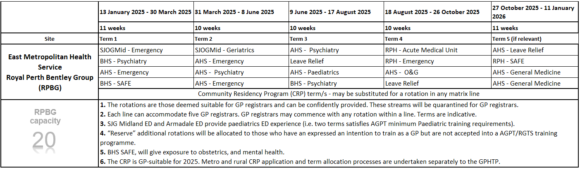
Appendix B: GPHTP GP-suitable Rotational Matrix 2025 – to be updated.
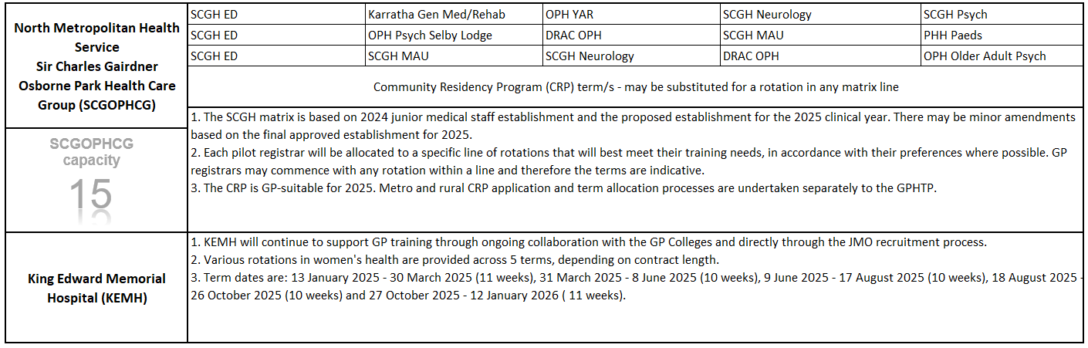
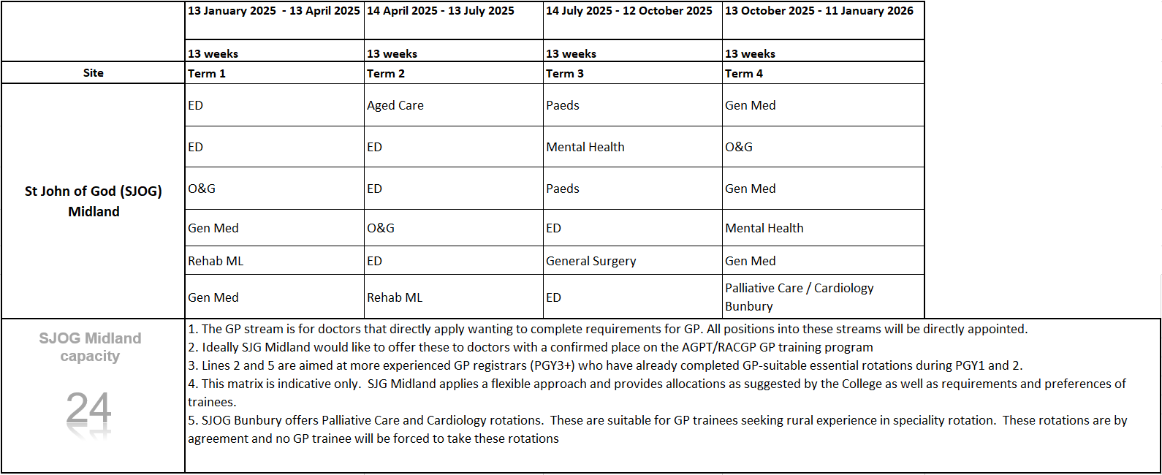
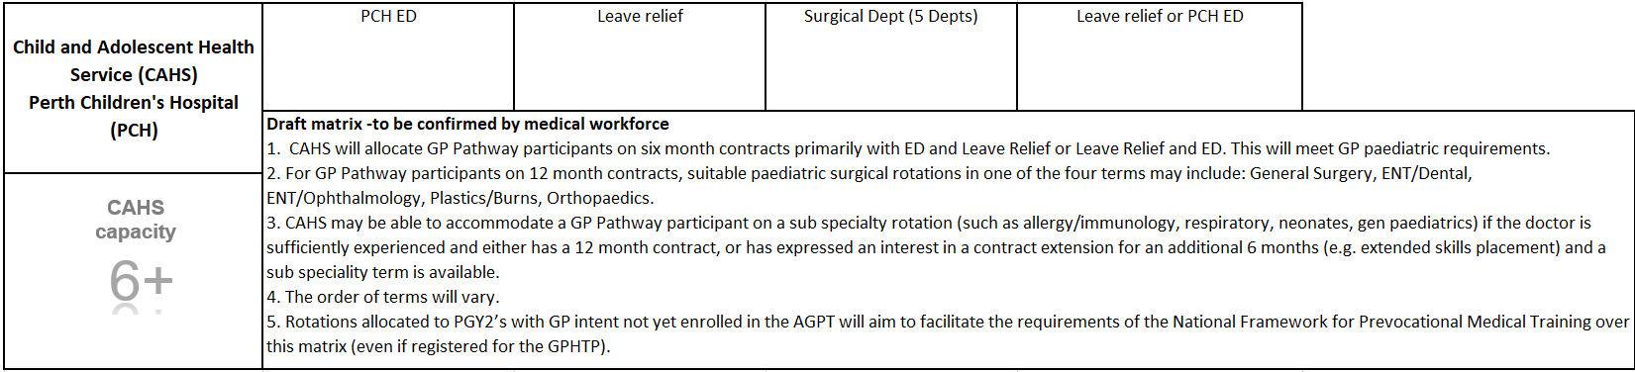
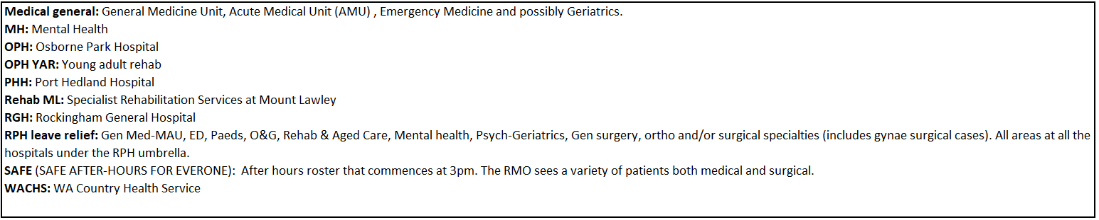
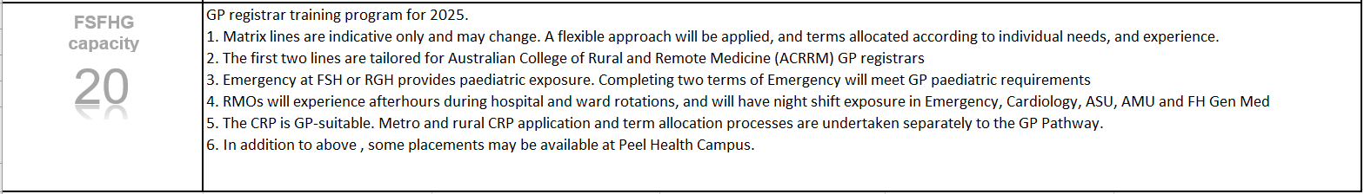
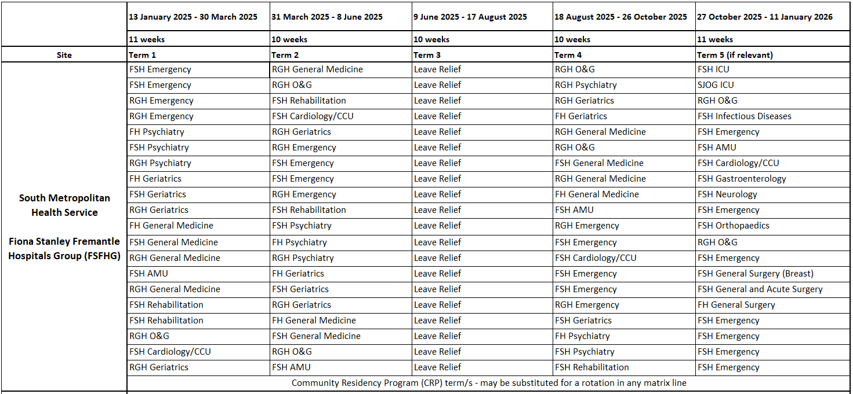
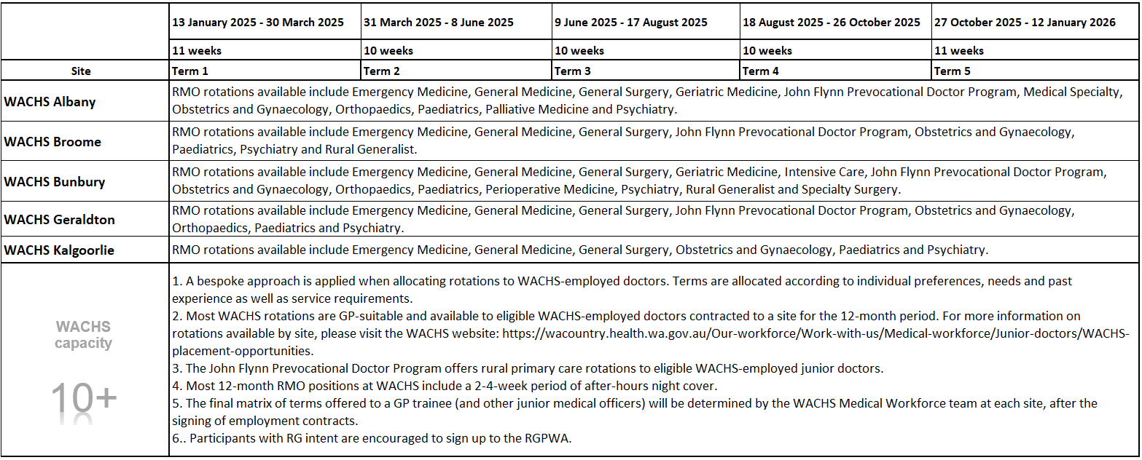
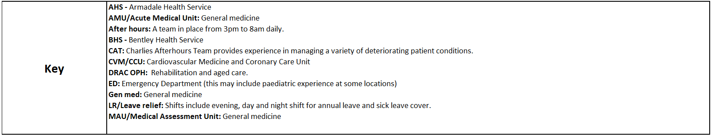
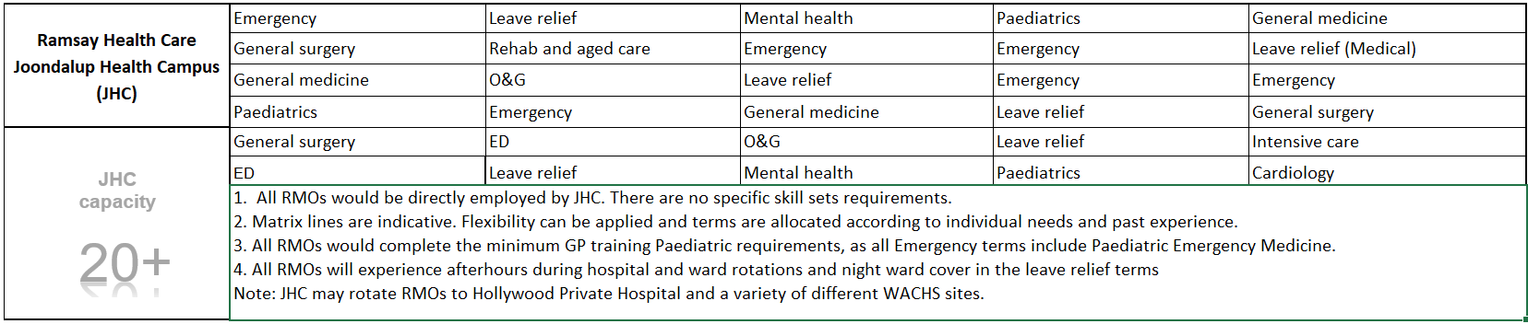

Appendix C: Key dates
The following timeframes will apply for 2025. Confirmed dates are in black, tentative dates are in blue.
Key Date (KD) # - Action | Resp | Date
KD #1 – Finalise GPHTP rotational matrix 2025 | EHSs | 1 May 2024
INTERDEPENDENCY- Centralised recruitment opens | N/A | 6 May 2024
KD #2 – Open GPHTP expression of interest (EOI) process | OCMO | 8 July 2024
KD #3 – Close GPHTP EOI processes | OCMO | 31 July 2024
INTERDEPENDENCY- ACRRM offers finalised for Intake 1, Semester 1 2025 | N/A | 19 July 2024
INTERDEPENDENCY- RACGP offers finalised for early intake (Round 1) | N/A | 3 July 2024
KD #4 –Tranche 1 GP Trainee recruitment and onboarding commences. Colleges to:  - Supply new GP trainee cohort information  - Send GPHTP onboarding survey link  - Identify returning GP trainees. | Colleges | RACGP – 10 July (Est)  ACRRM – 26 July (Est)
INTERDEPENDENCY – Centralised recruitment offers  - RMO Offers – 1st round  - RMO Offers – 2nd round  - Offer period closes | N/A | 13 September 2024
KD #5 - EHSs provide updated allocations for 2024 (OCMO to provide list) | OCMO/ EHSs | 30 August 2024
KD #6 – Send EHS’s their GPHTP participant information for 2025, including Rotation Guides (where applicable). | OCMO | By 27 Sept 2024
KD #7 – Commence Tranche 2 recruitment and onboarding | OCMO/ Colleges | ACRRM - from 11 October 2024  RACGP - Unknown
KD #8 – EHS provide the following allocations:  - completed (2024 cohort)  - baseline allocations (2025 cohort/Tranche 2 applicants). | EHSs | As early as possible from 2 December 2024.
KD #9 - Provide EHSs and Colleges with a final list of their GPHTP participants. | OCMO | By mid-February 2025
KD #10 - Submit the following to GPHTPC:  - Draft GPHTP Framework 2026  - Annual Report 2024 | OCMO | By early-March 2025
KD #11 - GPHTPC to endorse Framework and Annual Report | GPHTPC | By early-April 2025

Appendix D: Trainee Declaration
General Practice (GP) Hospital Training Pathway Trainee Declaration 2025
GP trainees
I, understand and accept the following while participating in the GPHTP, commencing in 2025:
Insert name here
- The aim of the GP Hospital Training Pathway (GPHTP) is to optimise my readiness for community GP training and/or further hospital GP training through the completion of a combination of GP-suitable rotations over one to two years.
- If I am confirmed to the GPHTP during Tranche 1 and will be employed for a minimum of six months at a non-specialist hospital, my college will review my training experience and preferences (provided in my GPHTP onboarding survey) and prepare a Rotation Guide. If I aAm confirmed in Tranche 2, I will receive a Rotation Guide if I return to the GPHTP for another 6-12 months.
- My Rotation Guide, if applicable, will provide my Employing Health Service (EHS) with high level recommendations on the specialty rotations that will support my preparation for the next stage of my GP training.
- My allocation to a combination of GP suitable rotations will be determined by my EHS/hospital Medical Workforce Team. They will consider my Rotation Guide, the requirements of the broader GPHTP cohort, and other circumstances such as service requirements when allocating rotations.
- While my EHS will endeavour to accommodate my preferences, their priority will be allocating me to the rotations recommended in my Rotation Guide, if applicable.
  - Hospital training requirements for GP trainees can include overtime, on-call and leave relief, and I may be allocated to these whilst on the GPHTP. A maximum of one term of leave relief is considered optimal.
  - I may rotate to other hospitals within my EHS to facilitate access to a combination of GP suitable rotations.
- Other GPHTP requirements include:
  - adherence to my employment contract/s
  - completing the GP-suitable rotations allocated to me by my EHS for the purposes of the GPHTP and/or ensuring that any changes to my rotations are beneficial in terms of my GP training.
  - endeavouring to participate in any education activities provided by my college during my hospital training time
  - participating in GPHTP monitoring, upon request.
- To support my ongoing participation on the GPHTP and optimise my training experience, my information may be shared between the Office of the Chief Medical Officer (OCMO), my college and/or my EHS. This may include, but not be limited to, my Rotation Guide, employment contract status, initial allocations and rotations completed whilst on the GPHTP:
- I will be supported by my GP College for the length of the GPHTP.
- It is my responsibility to understand and comply with GP College training requirements that are outside of the scope of the GPHTP.
- I will be transparent in my dealings with my EHS, College and OCMO. If my training and/or employment circumstances change at any time I will advise the relevant party so my records can be updated and my participation in the GPHTP reviewed.
- I will conduct myself in an honest, professional and ethical manner throughout my hospital training and the GPHTP.

☐ I have read the GPHTP Framework and understand that failure to meet any of the above requirements may result in a review of my suitability for inclusion in the GPHTP.

_____________________________ ____________________________
GP trainee signature (date) OCMO signature (date)

This document can be made available in alternative formats
on request for a person with disability.
© Department of Health 2024
Copyright to this material is vested in the State of Western Australia unless otherwise indicated. Apart from any fair dealing for the purposes of private study, research, criticism or review, as permitted under the provisions of the Copyright Act 1968, no part may be reproduced or re-used for any purposes whatsoever without written permission of the State of Western Australia.

