Consumer Focus Groups – Care Coordination for People with Disabilities

Disability Health Network
Care Coordination Working Group
Care Coordination Framework sub-group

September 2014



Contents
Background to the project 2
Method 4
Data analysis 4
Results 4
Discussion 6
Appendix 1: Focus Group Questions – People With Disabilities and Carers 7
Appendix 2: Summary of themes from Focus Groups 8
Appendix 3 : Demographic characteristics of participants 11

Background to the project
The WA Health Clinical Senate debate in June 2011 ‘Clinician – Do you see me?’ explored the experiences of people with disability and their carers when receiving health services. In a partnership between WA Health and the Disability Services Commission, the endorsed recommendations from the Senate are being progressed.
The recommendations were aimed at trying to improve the health outcomes of people with disability by improving the health service experience. One of the endorsed recommendations was to establish a Disability Health Network (DHN).
As a precursor to the establishment of the DHN, a consultative group was formed by Disability Services Commission in mid-2012 to seek further feedback from stakeholders and continue the momentum for change. The report from this Group has been used to inform the Executive Advisory Group (EAG) of the DHN.
The Network was launched on 1 November 2012 by the Minister for Disability Services and Mental Health. The scope of the DHN includes:
- Models of care/pathways/case management.
- Care planning (care plans).
- Preventative health strategies.
- Social inclusion.
- Attitudinal change (clinicians).
- Strategies for communication and linkage i.e. Disability Liaison Officer.
In June 2013, the Disability Health Network Care Coordination Working Group (CCWG) formed, co-chaired by Gordon Trewern (CEO Nulsen Disability Services) and Kate Bullow (Team Leader Complex Needs Coordination Team, South Metropolitan Health Service). The principle goal that the CCGW was asked to achieve was:

To develop a health care planning framework that uses a whole of person or person centred approach to facilitate effective health service design for people with disability to improve health outcomes. (CCWG Terms of Reference 2013)

Membership of the CCWG was by expression of interest and currently includes professionals from the Health Department, clinical hospital staff, community-based non-government organisations which offer services to people with a range of disabilities, Medicare Local, and consumer representatives. The Group is supported by the DHN including the DHN Co Leads Fiona Payne and Andrew Heath.
An initial task for the group was to define the term “Care Coordination”. In keeping with the original theme of the Clinical Senate, a definition focused on coordination of health care was developed:

"Care coordination" can be broadly defined as the systems and processes in place to ensure that health care for people with disabilities is managed consistently across the continuum of care, including in-patient and out-patient hospital care, primary care, patient self-management/carer management and the community and residential care sectors. Central elements of care coordination are effective transition of care (communication), and a holistic perspective of the needs and preferences of the person. (CCWG Terms of Reference 2013)
Through the development of this definition, and discussion of the experience and knowledge of group members, a number of key themes emerged.
- The need for a common care plan shared between all sectors of Health and disability/community services
- The challenges of “silos” and lack of knowledge of what is provided in different sectors, in particular limitations on group homes and other community living environments
- Historical, cultural and philosophical separations between health care and individual support planning by disability services
- Some care coordination services already exist – CCWG keen for more information from these services
- Limitations of general health care of people with disabilities including people not known to Disability Services Commission
Formal presentations to the CCWG by a number of existing services which provide a service which includes care coordination for people with disabilities provided further insight into what “care coordination” might look like. The group was also inspired by the progress made by the New South Wales Ministry of Health under their Service Framework to Improve the Health Care of People with Intellectual Disability (2012).
Two sub-groups of the CCWG were established, one focused on developing an effective communication document to improve transfer of care between disability care facilities/group homes and hospitals, and another to explore the current status of care coordination for people with disabilities in Western Australia and to develop recommendations for improvement including possible models of care.
The focus groups which are the subject of this report were the first stage of information gathering for the second sub-group.

Aims
The purpose of the focus groups was to explore the topic of “Care Coordination” and to gain insight into the experiences of the consumers of health services. It was hoped that this would provide some balance to the previous discussions of the CCWG which were primarily from the service provider’s perspective.

Method
Four focus groups were conducted over two days in June 2014. Twenty-one participants (8 people with disabilities and 13 people who identify as carers of people with disabilities) attended groups which ranged in size from four to seven participants.
Participants were recruited through a flyer forwarded by email through the networks of members of the DHN and widely circulated. Each person expressing interest was contacted and asked about any special needs that would need to be accommodated and preferences for time, date and venue. Of the 29 who originally responded to the flyer, two could not be accommodated at a time or venue suited to others, one person has special needs which could not be accommodated and two withdrew before final dates were set. Three were apologies on the day.
A reimbursement payment was made available to all attendees (managed by DHN for people with disabilities and Carers WA for carers). Taxi vouchers were provided to people with disabilities who required taxi transport. Food and drinks appropriate to dietary requirements were provided to all participants including attendant carers.
The same two facilitators conducted each group, with one person asking the focus group questions and the other recording notes of the discussions. Each participant had the opportunity to answer each question without interruption from other participants.
Questions for the focus groups have been appended (Appendix 1). In the allocated 1.5 hours, it was not possible to ask all of the questions for every group.

Data analysis
A breakdown of the characteristics of each group and all participants has been appended (Appendix 2).
Key themes from each group and over all across groups were identified through review of written recordings of the groups’ discussions.

Results
Focus group participants described a range of knowledge and awareness of the term “care coordination”, with about half stating that they had heard the term before. Several participants commented that “there is no care coordination”.
Most participants thought they had not received ‘formal’ care coordination. Carers who are parents of children and adults with disabilities considered that they are often the care coordinator, and expressed some frustration with the complexities of and lack of support in this role. Some people with disabilities stated that they are their own care coordinator, and that at times they may require support with this due to health fluctuations.

A number of health and community service professionals were identified as providing a specific care coordination role, including:
- General Practitioners (GPs)
- Local Area Coordinators - Disability Services Commission
- “CoNeCT” (Complex Needs Coordination Team) Care Coordinators – Metropolitan Health Services
Participants found it easier to describe negative experiences of care coordination than positive experiences, although many examples given were about general provision of services and system limitations rather than relating to coordination of care within or between services. Handover of care information within hospital, hospital discharge planning processes, and the transition of care from paediatric to adult health services are key areas where consumers have experienced poor care coordination with negative consequences.

“…something that I was quite vocal about when she was there [PMH], all the positive care of all the clinicians and everything was fine and now we have to transfer you, my understanding is there is not much change in the time from when she goes from being cared for as a person as Mary to go down to Charlies it’s only a 20 minute ride in the car, she goes from being Mary to a number….so I became quite vocal I have been snapping around shouting expressing that we are Mary’s Primary Carers and we need to be involved!” – Family Carer attending focus group (name changed)
“I was discharged from hospital and the services who I require weren’t advised accordingly beforehand. I certainly wasn’t advised before I was discharged… there wasn’t that coordination, I very much relied on the family to fill in the gap of getting my medications and things like that, they weren’t sure what to dispense and when to dispense there wasn’t that coordination for up to two days to get things back to normal, and that two days I more or less stayed in bed, so it wasn’t the best situation and possibly trying to recover…”.– Person with a disability attending focus group.

Responses to questions on the meaning of care coordination, positive and negative experiences of care coordination, and ways in which care coordination could be improved, indicate that from consumer perspectives there are three key aspects of care coordination:
- Facilitating communication between service providers to deliver care in a “team approach” – where the person with a disability and/or their carer is included as part of the team
- Providing a central point of contact for problem solving and using “insider” knowledge of health and disability systems to provide advice, advocacy and problem solving
- Overseeing all of the care that is being received to ensure that all of the needs of the person with a disability are being met
The challenge of meeting the expectations of consumers in providing care coordination became apparent through several conflicting themes that arose when participants described what they thought care coordination is and how it could be delivered.

Theme | Contrasting Theme
Having to explain your needs repeatedly is frustrating | The needs of a person with disability can change from day to day
Need someone who can work between all of the different services to bring everything together | Don’t need someone all the time, just when things are difficult or going wrong
Ask me what I want so I can tell you how to meet my needs | Don’t ask me “what do you want?” – I don’t know what my options are!

All groups acknowledged that the needs of people with disabilities are varied, that “having a disability” doesn’t automatically indicate a need for care coordination, and indicated that a flexible approach should be adopted based on meeting people’s needs rather than being focused on their diagnosis.
A summary of all of the themes is appended (Appendix 3).

Discussion
Focus group attendees demonstrated a variety of perspectives on care coordination based on their experiences. A lack of coordination by hospital-based services stood out as their main area of concern.
A wide range of preferences for care coordination delivery was revealed, with the common thread being that people would like support which is flexible and specific to their needs. Local Area Coordinators (Disability Services Commission) and Complex Needs Coordination Team (CoNeCT – Metropolitan Health Services) were identified as existing services which provide a flexible care coordination approach.
People with disabilities and carers will be surveyed further, along with key service provider groups (hospital health professionals, primary care health professionals, community based non-government organizations which provide support to people with disabilities) to further understand the current status of health care coordination for people with disabilities in Western Australia. This information will be useful in informing the transition to the National Disability Scheme, the Western Australian health system and the activities of the Western Australian Disability Health Network.

Appendix 1: Focus Group Questions – People with Disabilities and Carers
*****Introductions, pre-amble and brief ice breaker exercise******
Q1. Is the term “care coordination” one that you have heard before? What does it mean to you?
[need to be prepared to offer some definitions and explanations at this point if group unable to discuss]
Q2. If someone has a disability, do they need help with care coordination? In what situations might it be needed? Do you think that people with disabilities have different needs for care coordination compared with people who do not have a disability?
Q3 Are you able to talk about a good experience you have had with care coordination? What were the things that made it a good experience or were done well?
[prompt if no response – a good experience could be where there was good communication between different doctors, someone helped you after you had been in hospital]
Q4 Are you able to talk about a negative experience you have had with care coordination? What were the things that weren’t good?
[prompt if no response – a bad experience could be where different people were involved but they weren’t talking to each other about what they were doing]
Q5 What could be done to improve the coordination of care between different health services (e.g. GPs, hospital doctors, Silver Chain) and other services?
[prompt – some things that others have talked about include having a written document that everyone can access and add to, having a dedicated person or service you can contact for help, more education about disability for health workers]
Q6 Later this year there is a going to be a survey of people with disabilities, carers and people who provide health and disability services. Are there any important questions that we should ask each group?
- People with disabilities
- Carers
- Services
Q7 Can you suggest a good definition of Care Coordination which would make sense to other people who have experience with disability?

Appendix 2: Demographic Characteristics of Participants

Group A (5 participants)
Person with disability | No people with a disability
Carer | 5 carers
Age | Average age = 51.0 Range 39:68
Gender | 5 Female

Group B (6 participants)
Person with disability | 4 people with a disability
Carer | 2 carers
Age | Average age = 58.0 Range 35:73
Gender | 5 Female 1 Male
Group C (7 participants)
Person with disability | 3 people with a disability
Carer | 4 carers
Age | Average age = 55.7 Range 34:72
Gender | 5 Female 2 Male
.
Group D (5 participants)
Person with disability | 2 people with a disability (1 also a carer)
Carer | 4 carers (1 also a person with a disability)
Age | Average age = 47.0 Range 38:54
Gender | 5 Female

People with a Disability (9 participants)

Type of disability
- 8 have a physical disability
- 2 have a mental health disability
- 2 have an intellectual disability
- 2 have a communication disability
- 1 has a sensory disability
- 1 has a cognitive disability
- 4 have a disability which has been life-long
- 5 have a disability which began more than 5 years ago

Living and informal care arrangements
- 5 live alone
- 3 live with others (non-carer)
- 1 lives with carer
- 4 do not have an informal carer
- 3 have informal carers they are related to, 1 spouse, 1 parent and 1 other family member
- 2 have carers that they are not related to

Formal care arrangements
- Average number of formal care hours per week is 14.6
- 2 have no formal care hours
- 2 have more than 35 hours per week

Carers (14 participants)

Type of disability
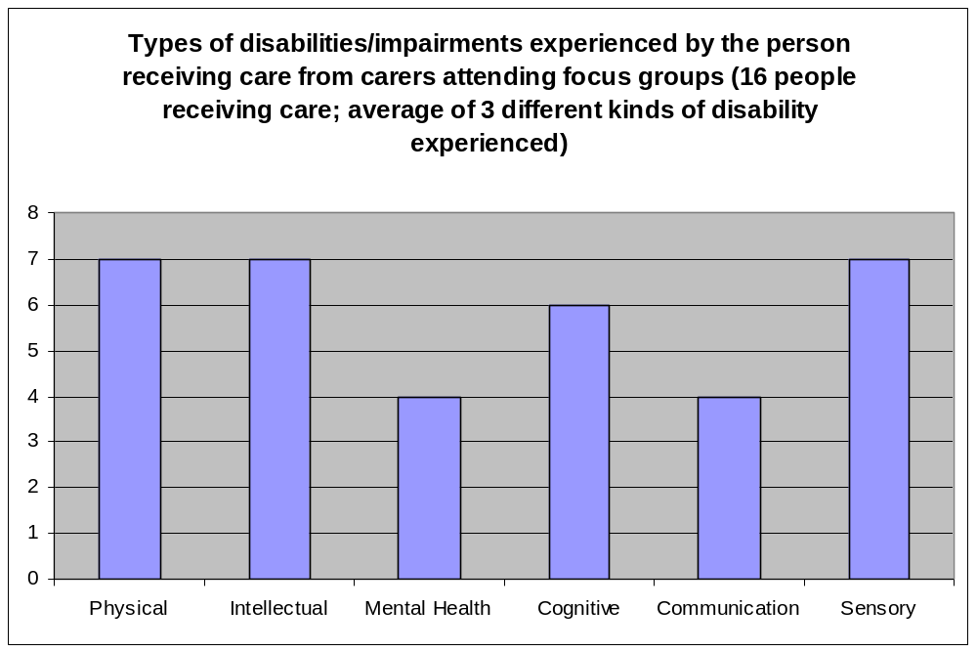

Living arrangements and relationship
- 11 carers live with the person they care for
- 3 carers do not live with the person they care for
- 12 carers care for their child
- 2 carers care for someone with another family relationship

Appendix 3: Summary of themes from Focus Groups
- Communication between service providers (“a team approach”)
Care coordination occurs when:
- Health service providers talk to each other/work together/collaborate/share information
- Health service providers also communicate/collaborate with other service providers in areas such as social care, education, disability services
- Service providers have a multi-disciplinary ‘team approach’ where the consumer/support team is included in the team
- There are regular team meetings to discuss care and future goals
- The different disciplines that communicate/collaborate together include:
  - GPs
  - Medical specialists (“doctors”)
  - Therapy specialists (e.g. Occupational therapists, physiotherapists)
  - Psychologists
  - Social workers
  - Community pharmacists
  - Education system
  - Disability services
  - Not-for-profit/non-government organisations
- A central ‘go to’ person similar to a case worker/LAC (“case coordinator”)
- An ‘insider’ who knows how the system works, has knowledge
- A constant/consistent person
- A “one-stop shop”
The role/functions of the case coordinator include:
- Listen to and understand the needs of the consumer:
  - Assess care needs – ask the person
  - Listen to parents/carers (“the oracles”)
  - Write down medical history/electronically record medical history so it can be given to service providers
  - Validate/acknowledge the reality/rights of consumers
  - Be aware of and understand the nature of the health condition(s) and needs of the person
- Develop a relationship with consumer:
  - Build the relationship and develop rapport
  - Get to know the person/carer and maintain an ongoing relationship
- Provide information on:
  - What is needed to care for the consumer in the community
  - What the consumer needs to do/think about
  - What help/aids are available
  - How to link services together
- Connect consumer to:
  - Appropriate services (once their care needs are understood)
  - Family support (including for siblings)
- Organise logistics
  - Coordinate appointments between different service providers
  - Coordinate appointments taking into account the needs of other family members (where carers have other children and caring responsibilites)
- Be an advocate for the person with a disability
  - Important that someone within the system provides the advocacy
- Liaise with service providers to:
  - Have an overall picture of services provided to the consumer (e.g. medical, social, support workers)
  - Pull service providers together to adopt a “team approach”
  - Break down silos between service providers
  - Be an advocate for the consumer
- Conduct regular meetings with:
  - Service providers (e.g. attend multi-disciplinary team meetings)
  - Coordinators at various support agencies
- Provide carer/family support:
  - Understand and recognise the carer/whole-of-family needs
  - Look at the family as a whole
  - Oversee accountability of what people (parents/carers) are supposed to do for PWD
- Develop plans:
  - Care plans
  - Living plans
- Assist with funding:
  - Help with funding applications with different agencies/different funding streams
- Solve care problems: (no examples given)
- Provide objective coordination without bias (not sure what this actually means)
The location of the case coordinator could be:
- An agency/service provider
- In the community
- CoNeCT
- Part of the disability services
- In disease-specific community organisations (e.g. patient support groups) where care is coordinated for people with that particular disease
An issue is being able to trust the agency.
- When care coordination is needed
- At the point of diagnosis
- Acute and long term care
- At transitions from:
  - Paediatric to adult care
  - Health services to disability services
  - Health services to community care
  - Hospital to home (i.e. as part of discharge planning)
Whether PWD need care coordination depends on the context (“it’s an individualized thing”):
- Type of disability (‘disability’ is a broad term, how is it being defined?)
  - Level of impairment
  - Cognitive capacity
  - Whether PWD has multiple issues (e.g. physical, intellectual, medical/therapy needs)
  - Functional need
  - Long term complex needs
- Individual coping skills
- If multiple agencies involved – government, NGO’s
- If PWD doesn’t have family around them
Flexibility is needed as:
- Care needs can be different at different times
- 1 size doesn’t fit all
- Can try new things and go back to old ways if PWD prefers
- Benefits of care coordination
The main benefits of care coordination are perceived to be:
- Everyone understands the condition/needs of the PWD
- Everyone knows what is going on
- Everyone is on the same page/has the same idea of what is needed
- PWD/carers don’t have to repeat medical history information all the time
- Things are smooth and efficient
- Seamless contact between service providers
- Care is not fragmented
- The PWD is cared for as a person and not a number
- A ‘holistic’ view is taken of the PWD (e.g. physical, mental, all issues) and ‘holistic care’ is provided. The PWD is seen as a ‘whole person’, a package and not stand alone conditions/body systems
- The family is better supported
- The best outcomes are achieved for the patient



This document can be made available in alternative formats
on request for a person with a disability.
© Department of Health 2014
Copyright to this material is vested in the State of Western Australia unless otherwise indicated. Apart from any fair dealing for the purposes of private study, research, criticism or review, as permitted under the provisions of the Copyright Act 1968, no part may be reproduced or re-used for any purposes whatsoever without written permission of the State of Western Australia.

