Disability Health Framework 2015–2020
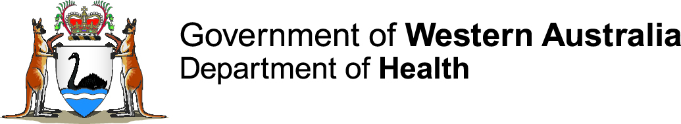
Improving the health care of
people with disability
Easy English version

There are some hard words in this book. The first time we write any hard words they are in blue.
We will write what hard words mean.
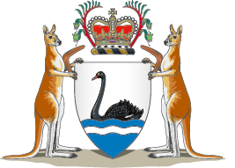 | The Disability Health Network wrote the Framework. For Disability Health Network we will write the Network.  The Network is a group of people. They all want people with disability to have better health care.
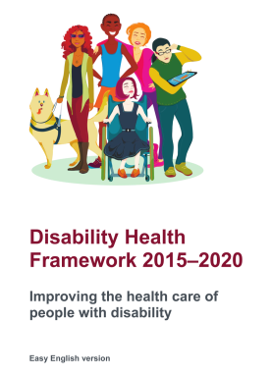 | This book is about the Western Australian Disability Health Framework 2015–2025: improving the health care of people with disability.  We will write the Framework in this book.  Lots of people including people with disability, their families and carers have helped to write the Framework.

The Framework is important to all organisations that provide health care. For example,
- hospitals
- general practitioners
- dentists
- specialists
The Framework is also important to all organisations that support people with disability to live a good life.

The law
There are laws that say people with disability have rights.
Rights are the things that everyone should be able to
- get
- have
- do
One right is to have a good life. People with disability have the right to be healthier, so they can have a good life.
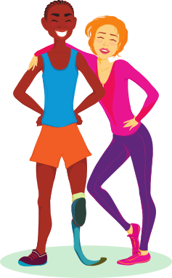 | What will help people with disability be healthier?  - Health organisations should understand more about people with disability.  - Health organisations should make people with disability feel welcome.  - Health organisations should make sure that their buildings are easy for people with disability to access.  - When health organisations work with people with disability they should be flexible.  - When health organisations work with people with disability they should be respectful.  - Health organisations should work together with people with disability, their families and carers.  - When health organisations work with people with disability they should always try to work better.
 | Respect means that we treat people in a way that shows we care what they think and feel.

What needs to change?
There are four main things that need to be changed.
- Health organisations and the community should understand the different needs of people with disability.
- Health organisations and the community should work with people with disability, their families and carers to make everyone healthier.
- Health organisations and the community need to teach their workers about the different needs of people with disability.
- Health organisations and the community should make it easier for people with disability to get the health care they need.

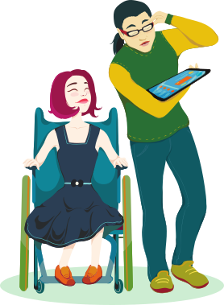 | Whose job is it to make things better?  It is everyone’s job to work together with the person with disability so they can have a healthy and good life.  People who make decisions about how health and disability organisations work must make sure that they help people with disability to be healthier.  Health and disability workers must give good care to people with disability, their families and carers to make them healthier.  People with disability, their families and carers should have help to understand how to be healthier and have a good life.

How will we make changes?
To make the changes it is important to talk to people with disability about what they need.
Health and disability organisations should also talk to each other to make sure they work together.

Information
Health and disability service organisations might ask you for information. This is to get better at helping people with disability.
You only have to tell them information that you are happy to share. You can say no.

How will we know if this Framework works?
People who use the Framework will be asked if it works.
People with disability will feel more involved in their health care if the Framework works.

Contact us
Health Networks, Department of Health
9222 0200
Healthpolicy@health.wa.gov.au
Department of Communities – Disability Services
9426 9200
DSenquiries@communities.wa.gov.au

This document can be made available in alternative formats
on request for a person with a disability.
© Department of Health 2017
Copyright to this material is vested in the State of Western Australia unless otherwise indicated. Apart from any fair dealing for the purposes of private study, research, criticism or review, as permitted under the provisions of the Copyright Act 1968, no part may be reproduced or re-used for any purposes whatsoever without written permission of the State of Western Australia.

