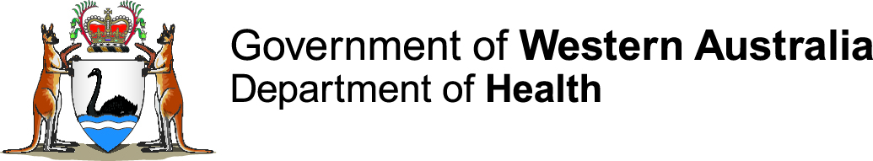

Public Health Emergency Coordination Centre

Communique
Security | Public
Distribution | Widespread distribution - metropolitan, regional, public
Target audience | All stakeholders

Incident Name: Targeted Regional WA MenW Outbreak Response

Communique. 3 (covers period 23.10.2017-29.10.2017). New information in bold, blue font.

Day, date and time: Friday, 3 November 2017

This communique has been authorised by: Dr Paul Armstrong

Background
- Invasive meningococcal disease (IMD) due to meningococcal serogroup W (MenW) has risen rapidly across Australia since 2014.
- A statewide MenACWY vaccination program for 15-19 year olds commenced in April 2017 and is still continuing.
- An outbreak of MenW in central Australia started in July 2017. Aboriginal people living in communities across a broad area in the Central Australia, Barkly, and Katherine regions of the Northern Territory (NT) and the Anangu Pitjantjatjara Yankunytjatjara (APY) Lands of South Australia (SA) have been affected. There has been one related case reported in WA.
- Meningococcal ACWY (MenACWY) vaccination programs have been introduced in the NT and the APY Lands in response to this outbreak.
- To prevent further transmission and cases of MenW, WA Health will offer free MenACWY vaccination to all people aged 2 months and over living in Aboriginal communities that have strong cultural links with central Australian communities affected by the outbreak, i.e. the Ngaanyatjarra Lands and Tjuntjuntjara (Goldfields); Balgo, Bililuna, Kundat Jaru (Ringer Soak) and Mulan (Kimberley); and Punmu, Kunawarritji, Parnngurr (Cotton Creek), and Jigalong (Pilbara).
- The estimated target population is 3,300 people.
- The targeted vaccination program will be implemented from 18 October to 17 December 2017.

Current situation
Cases linked to the central Australia outbreak (NT, SA, WA)
- Total number of cases: 29
- Total number of deaths: Nil
WA cases linked to the central Australia outbreak
- Total number of cases: 1
- Total number of deaths: Nil
Communications
- Clinician advice, FAQs and other resources has been published, circulated and posted on the Healthy WA and the Health Professionals website.
Other:
The NT vaccination program has recently expanded to include non-Aboriginal people living in Alice Springs, Tennant Creek and Katherine.

Summary of MenACWY vaccine doses administered and estimated vaccination coverage (%), data extracted on 23.10.2017
 | Goldfields |  | Kimberley |  | Pilbara |  | Total
 | 2-11 months | 12 months and over | 2-11 months | 12 months and over | 2-11 months | 12 months and over | 2-11 months | 12 months and over
Vaccine doses administered before 16.10.2017¹ | 0 | 82 | 0 | 71 | 0 | 27 | 0 | 180
Vaccine doses administered, 16.10.2017 onwards | 0 | 333 | 4 | 375 | 0 | 0 | 4 | 708
Total vaccine doses administered to date | 415 |  | 450 |  | 27 |  | 892
Total population² | 1769 |  | 798 |  | 714 |  | 3281
Estimated coverage | 23% |  | 56% |  | 4% |  | 27%

1. The majority of these figures represent those who have received vaccine as part of the statewide MenACWY vaccination program for 15-19 year olds that commenced in April 2017.
2. Australian Bureau of Statistics (ABS) 2016 census.
Please note: Regional population estimates are based on 2016 census, however, populations will vary due to significant movement of people. Vaccination coverage should consider local population estimates at time of vaccination.

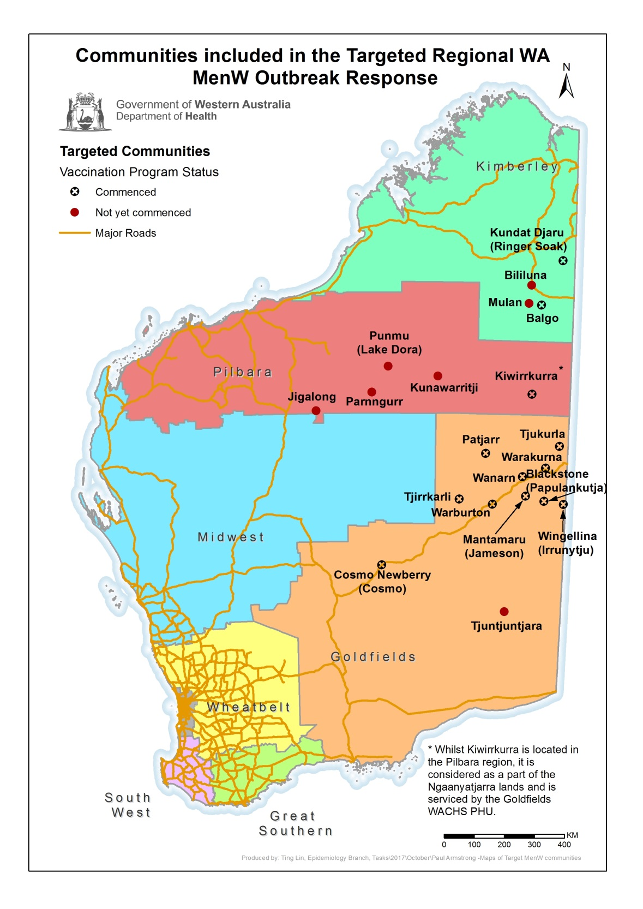

Further communiques
- The next communique will be issued on 10.11.2017.
WebEOC Incident Name: 20171012 Targeted Regional WA MenW Outbreak Response
Communique prepared by: Jenny Vo
T: +61 8 9388 4801 (0800-1700) | F: +61 8 9388 4801 | E: pheoc@health.wa.gov.au | I: www.health.wa.gov.au
The contents of this e-mail transmission are intended solely for the named recipient(s), may be confidential, and may be privileged or otherwise protected from disclosure in the public interest. The use, reproduction, disclosure or distribution of the contents of this e-mail transmission by any person other than the named recipient(s) is prohibited. If you are not a named recipient please notify the sender immediately.

